2.1 – ANGLES IN STANDARD POSITION

Definitions:
- On a cartesian plane, an angle is in standard position when its vertex is at the origin and when its initial arm is on the positive side of the x-axis.
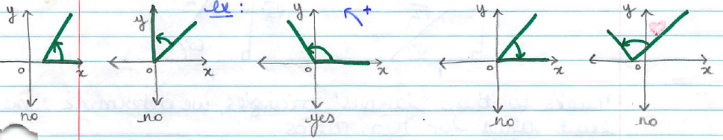
- The x- and y- axis divide the plane into 4 quadrants, numbered as follow:
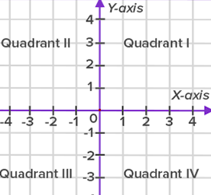
- Each angle in standard position is associated with a reference angle: an acute angle whose vertex is at the origin and measures the smallest angle between the terminal arm of the angle in standard position and the x-axis.
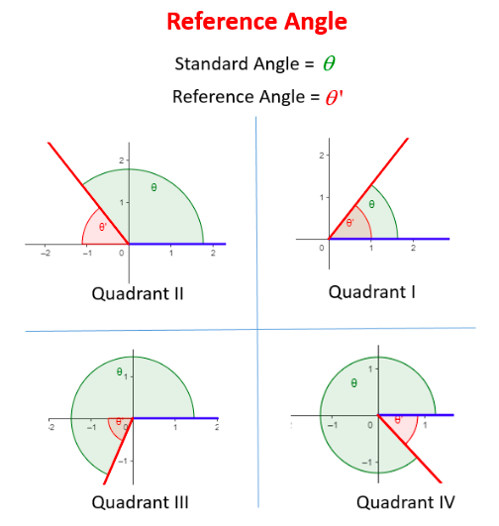
Examples:
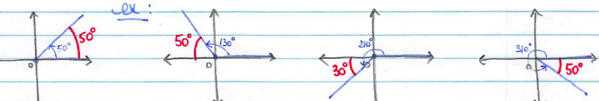
Note that the relationship between the angle and its reference angle is different depending on the quadrant.
Note that for each reference angle, there are 4 possible angles in standard position. (between 0º and 360º)
For example, if the reference angle is 40º, then the angle can be: 40º, 140º, 220º or 320º.

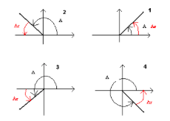
Note that if the rotation between the initial arm and the terminal arm is counter clockwise, then the angle has a positive value, otherwise, it is negative.
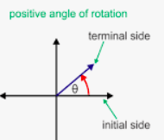 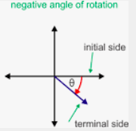

Special Values to Remember by Heart:

There are 5 different angles for which we need to remember the exact trigonometric ratios (sin, cos and tan).
Some of these angles and values can be noticed using 2 special triangles:

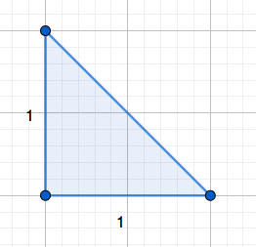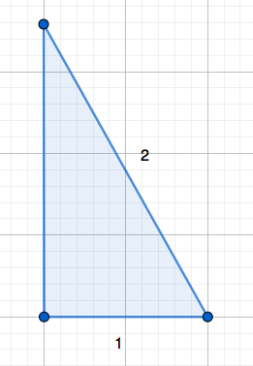

Using these triangles, we can get the exact values of :

$\cos{30°}$ $\sin{30°}$ $\tan{30°}$
$\cos{45°}$ $\sin{45°}$ $\tan{45°}$
$\cos{60°}$ $\sin{60°}$ $\tan{60°}$

We can already notice that the exact values of sin and cos and the same 3 ones.
The special values of tan are different.

Using SOH CAH TOA we notice that. $\frac{sinθ}{cosθ}=\frac{ \frac{opp}{hyp} }{\frac{adj}{hyp}}= \frac{ opp. }{adj}=tanθ$
We can already remember (for the future) that: $\tan{θ= }\frac{ \sin{θ} }{\cos{θ}}$
We can remember the special values by remembering the special triangles or from the unit circle.
The Unit Circle:
It is the circle with radius 1 centered at the origin.
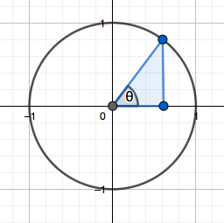
Angles in standard position are located by their corresponding point on the unit circle (intersection between the terminal arm and the circle).

Because of the radius is 1, then the hypotenuse of the right triangle including the reference angle is 1.
As a consequence, each point on the unit circle has coordinates $(\cos{θ ,\sin{θ)}}$, which is a very important property of the unit circle to remember.

We can remember the special values of the special angles by positioning them on the unit circle:
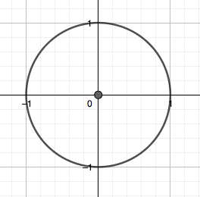
Note: This enables us to determine the exact ratios for the quadrantal angles (0º and 90º)

Hwk: p 83 # 1 – 7, 9, 11, 13, 17, 19, 20 + “Using the unit circle to approximate trigonometric ratios” worksheet.

