Using the unit circle to approximate trigonometric Ratios

Give your best approximation of the following Ratios using the given unit circle:

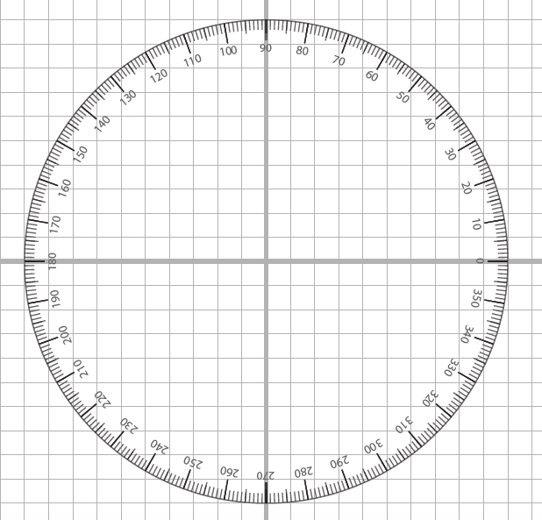

$\cos{20°}$ $\sin{30°}$ $\sin{40°}$
$\cos{50°}$ $\sin{60°}$ $\cos{70°}$
$$\cos{80°}$$ $\sin{90°}$ $\sin{0°}$

$\cos{0°}$ $\sin{10°}$ $\cos{90°}$

