2.2 – TRIGONOMETRIC RATIOS OF ANY ANGLE

In grade 10, we have defined trigonometric ratios for acute angles (between 0º and 90º) in a right triangle using SOH CAH TOA.

This year, we will extend the definition to any angle (not necessarily part of a right triangle).

You need to remember that the sign of a ratio depends on the quadrant of the terminal arm, and the numerical value (without the sign) depends only on the reference angle.

If we remember that the cos and sin values can be found on the unit circle with the coordinates of the points on the circle, and that $tan θ= \frac{ \sin{θ }}{\cos{θ}}$, then we get:
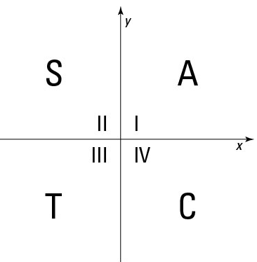
We remember which ratio is positive with the acronym ASTC:

“All Students Take Calculus”

Applications: Determining a Ratio I suggest to always sketch the situation

Examples: Finding a Ratio when the reference angles are SPECIAL:
Use the quadrant and the reference angle
a) determine $\cos{150°}$:
b) determine $\sin{225°}$:
c) determine the 3 trigonometric ratios for 300º:

Examples: Finding a Ratio when the reference angles are NOT SPECIAL
You just need to type it in your calculator
Determine an approximation of $\cos{137°}$ to the nearest hundredth:
Note that the sign of the answer makes sense…

Examples: Finding an exact Ratio when we don’t know the angle:
You will need to use SOH CAH TOA in a right triangle involving the reference angle

a) P(-8, 15) is on the terminal arm of an angle $θ$ in standard position.
Determine the exact values of the 3 trigonometric ratios $\sin{θ}$, $\cos{θ} and \tan{θ}$.
Note that if you try to find the angle, you won’t get an exact value…
b) An angle $θ$is in quadrant III and we know that $\cos{θ= -\frac{3}{4}}$.
Determine the exact values of $\sin{θ} and \tan{θ}$

Applications: Determining Angles given a Ratio – Solving Equations
Determine the quadrant(s) using the sign, and the reference angle using the value,
Then position the reference angle in the possible quadrants to find the angle(s)

Examples: when the Ratios are SPECIAL

a) Solve $\cos{θ}=\frac{1}{2}$ for $0°≤θ≤360°$
b) Solve $\sin{θ}=-\frac{\sqrt{2}}{2}$ for $0°≤θ≤360°$
c) Solve $\tan{θ}=-\sqrt{3}$ for $0°≤θ≤360°$

d) Solve $3\tan^{2}{θ}=1$ for $0°≤θ≤360°$

Examples: when the Ratios are NOT special

a) Solve $\cos{θ}=-0.3$ for $0°≤θ≤360°$

b) Solve $\sin{θ}=-\frac{1}{3}$ for $0°≤θ≤360°$

Hwk: p 96 # 1 – 13, 15, 18, 19, 22, 29.

