2.3 – The Sine Law

Reminders :
- An oblique triangle is a triangle that has no known right angle.
- Solving a triangle means determining the measures of all of its side and angles.

Up until now, we only have used trig ratios in right triangles (SOH CAH TOA).

The Sine Law can be applied on any type of triangle.

Using standard notations, the Sine Law states:
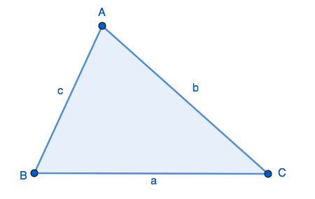

$$\frac{\sin{A}}{a}=\frac{\sin{B}}{b}=\frac{\sin{C}}{c}$$

Proof :

Applications :
- Determining a side length :
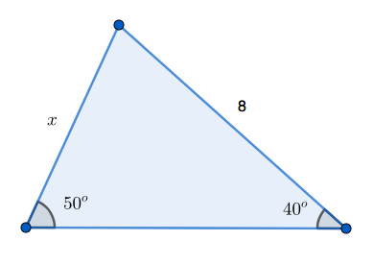

Your turn :p 103

- Determining an angle :
a) Determining an acute angle :
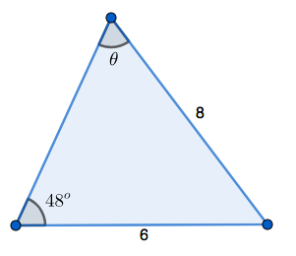
Your turn :
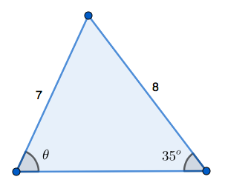
b) Determining an obtuse angle :
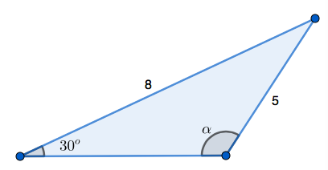

Hwk : p 108 # 1 – 4, 10, 11, 24
c) The Ambiguous Case

Sometimes, the info we get is not enough to know if we’re looking for an acute or an obtuse angle (either because we can’t see the angle of it is not drawn to scale…). In this case, we need to solve both possibilities and give 2 different answers.

Example : Consider triangle $⊿$ABC with standard notations such that $∠$A = 35º, $a=6$cm and $b=8$cm.
Determine $∠$B.

Here, we don’t know which of the 2 options (drawn on the next page)Ici, on ne peut pas savoir à laquelle des options ci-aprèwe are dealing with. We don’t know if $∠$B is acute or obtuse…
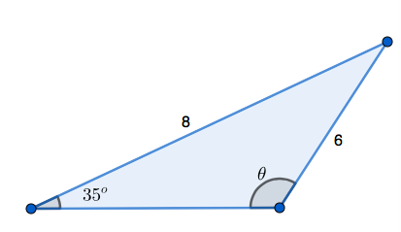 or 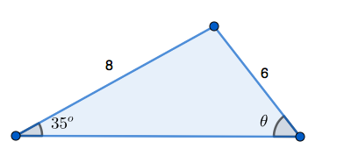

- Determining the number of possible triangles, knowing side lengths and angles:

If we are given less than 3 measurements, there are usually an infinity of possible triangles.
a) If we are given 3 side lengths:
There is exactly 1 possible triangle as long as the sum of 2 side lengths is always greater than the 3rd one.
We can draw the triangle using a compass.
Example: $⊿$ABC such that $a=3$cm, $b=4$cm and $b=6$cm.

b) If we are given 2 side lengths and 1 angle:

- If the given angle is between the 2 side lengths, then there is only 1 possible triangle.
Example : $⊿$ABC such that $∠$A = 35º, $b=3$cm and $c=4$cm.

- If NOT, ATTENTION there can be 0, 1 or 2 possible triangles !!
We will need to determine the height of the triangle to see if the given length is long enough.
Example : $⊿$ABC such that $∠$A = 30º, $a=3$cm and $b=8$cm.

Example : $⊿$ABC such that $∠$A = 30º, $a=4$cm and $b=8$cm.

Example : $⊿$ABC such that $∠$A = 30º, $a=5$cm and $b=8$cm.

Example : $⊿$ABC such that $∠$A = 30º, $a=9$cm and $b=8$cm.

c) If we are given 1 side length and 2 angles :

2 angles, is equivalent to 3 angles (because the sum of the 3 angles equals 180º).
There will be exactly 1 possible triangle. We will trace it using a protractor.

Example : $⊿$ABC such that $∠$A = 45º, $∠$B = 65º and $b=4$cm.

Hwk : p 108 # 5, 8, 9, 17

