2.4 – THE COSINE LAW

Using standard notations, the cosine law is:
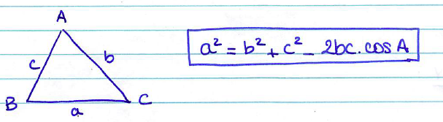
This formula works for any type of triangle.

Example 1: Determining a length
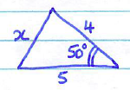
Example 2: Determining an angle
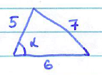
Example 3: Determining an angle
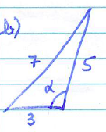

There is no ambiguous case with the cosine law.
If cos x is negative, the angle is obtuse, and the calculator will give the corresponding angle directly.

Hwk: p 119 # 1ac, 2ac, 4abde, 5, 7, 8, 10, 14, 15, 20, 23, 26.

