**Chapter 2 TEST**

Calculator Part

**Short Answer**

**1.** A drive belt wraps around three pulleys, A, B, and C, as shown.

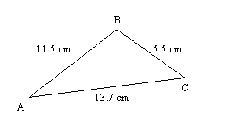

What is the measure of B to the nearest tenth?

**____ 2.** Determine, to the nearest tenth of a degree, the measure of B.

|  |  |  |  |
| --- | --- | --- | --- |
|  |  |  |  |
|  |  |  |  |

**3.** Gursant and Leo are both standing on the north side of a monument that is 6.0 m tall. Leo is standing 3.5 m closer to the monument than Gursant. Leo measures the angle from the ground to the top of the monument to be 41°. Determine the angle that Gursant would measure from the ground to the top of the monument, to the nearest degree.

**4.** In , *c* = 11 cm, *b* = 7 cm, and .

**a)** Sketch possible diagrams for this situation.

**b)** Determine the measure of C to the nearest degree in each diagram.

**c)** Calculate the length of BCin only one of the diagrams (the one that you choose).

NON-Calculator Part

**Multiple Choice**

**____ 5.** What is the reference angle for 265 in standard position?

|  |  |  |  |
| --- | --- | --- | --- |
| **A** | 5 | **C** | -95 |
| **B** | 85 | **D** | 65 |

**____ 6.** What is the exact value of A?



|  |  |  |  |
| --- | --- | --- | --- |
| **A** | 60 | **C** | 45 |
| **B** | 25 | **D** | 30 |

**____ 7.** What is the exact value for $tan⁡(150°)$?

|  |  |  |  |
| --- | --- | --- | --- |
| **A** |  | **C** | $-$ |
| **B** |  | **D** |  |

|  |  |  |  |
| --- | --- | --- | --- |
|  |  |  |  |
|  |  |  |  |

**Short Answer**

**8.** Determine the exact value of *x*.

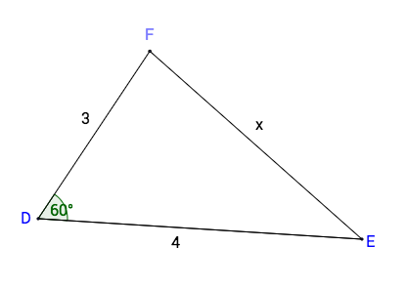

**9.** Determine the exact values of the following ratios and say what the reference angle is.

**Reference angle**

**i)** cos 45° = 🡪

**ii)** tan 300° = 🡪

**iii)** sin 240° = 🡪

**10.** The point A(–3, –5) is on the terminal arm of an angle . Determine exact expressions for the primary trigonometric ratios for the angle.

**11.** Solve the following equations for $0°<x<360°$.  
a) $cosx=\frac{1}{2}$

b) $sinx=-\frac{1}{\sqrt{2}}$

**c) $tanx=1$**