Quadratic Functions in Vertex Form

A quadratic function can be written in different forms.

Ex : Standard form $y=ax^{2}+bx+c$ ex : $f\left(x\right)=3x^{2}-5x+1$
Factored form ${y=a(x-x}_{1})(x-x_{2})$ ex : $g\left(x\right)=2(x-1)(x+3)$
The Vertex Form looks like : $y=a{\left(x-p\right)}^{2}+q$

Ex : $y=2{\left(x-3\right)}^{2}+5$ $a= , p= , q=$

$y={\left(x+1\right)}^{2}+3$ $a= , p= , q=$

$y=\frac{1}{2}{\left(x-3\right)}^{2}-2$ $a= , p= , q=$

When a quadratic function is in Vertex Form, $p$ and $q$ are the coordinates of the vertex.

Ex : $y=2{\left(x-3\right)}^{2}+5$ vertex :

$y={\left(x+1\right)}^{2}+3$ vertex :

$y=\frac{1}{2}{\left(x-3\right)}^{2}-2$ vertex :

Coefficient $a$ still tells us the direction of the opening and its “speed”.
Example 1 : $y={\left(x+1\right)}^{2}+3$

Example 2 : $y=2{\left(x-3\right)}^{2}-5$

From the vertex, you can use the “speed of opening” compared to the reference quadratic function of a table of values (choosing preferably one side of the vertex)…

Note : If you know the sign of $q$ and the direction of opening $(a)$,
you can easily know the number of $x$-intercepts
Ex : If $a>0$ and $q>0$,
If $a>0$ and $q<0$,
Determining an equation of a parabola :
If you can see the coordinates of the vertex on a graph, the easiest is to use the vertex form:
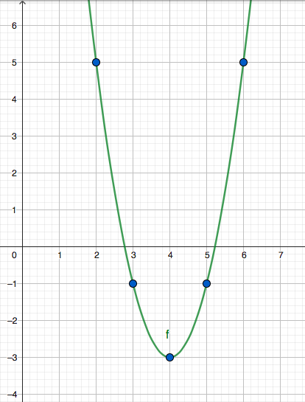

Hwk : p 157 # 4, 7, 8, 9, 12, 15, 16, 18, 20 + 21

