Changing the form of a quadratic function

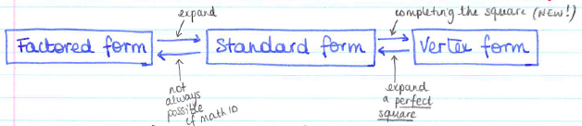

I – Changing into Standard Form : EXPANDING

Example 1 : $y=(x-3)(x+2)$

Example 2 : $y=-3(x-5)(x+1)$

Your Turn : $y=(x-7)(x-1)$ $a=1, b=-8, c=7$
$y=-2(x+1)(x+4)$ $a=-2, b=-10, c=-8$

Example 3 : $y={\left(x-1\right)}^{2}+3$

Example 4 : $y=-2{\left(x+3\right)}^{2}-5$

Example 5 : $y=-9{\left(x-\frac{1}{3}\right)}^{2}+4$
II – Changing into Factored Form: FACTORING

Always start by looking for common factors.
Think about differences of squares, perfect squares, otherwise, factor the long way…

Example 1 : $y=3x^{2}-9x$

Example 2 : a) $y=3x^{2}-75$ b) $y=4x^{2}-1$

Example 3 : $y=x^{2}+5x+6$

Your turn : $y=x^{2}-x-6$
$y=8x^{2}-2$
$y=x^{2}+13x+12$

Example 4 : $y=3x^{2}+8x+4$

Example 5 : $y=-6x^{2}-x+2$

Example 6 : $y=4x^{2}+12x+9$

Your turn : $y=2x^{2}+3x+1$
$y=5x^{2}-3x-2$
$y=x^{2}-10x+25$
III – Changing into Vertex Form : COMPLETING THE SQUARE

You have to regroup all the terms in $x$ and $x^{2}$ in a “forced” perfect square and compensate…

Example 1 : $y=x^{2}-4x+2$

Example 2 : $y=3x^{2}-18x+20$

Your turn : $y=x^{2}+6x-5$
$y=-2x^{2}+8x-3$
$y=3x^{2}-3x+1$

It becomes complicated very fast, especially when fractions start appearning…
We are going to actually use a shortcut:
- Coefficient $a$ is the same one in every form
- If we know how to find the coordinates of the vertex, we just need to place $p$ and $q$ in the formula…

Examples : $y=x^{2}+6x-5$ $y=-2x^{2}+8x-3$ $y=3x^{2}-3x+1$

Hwk : p 192 # 1, 2ac, 3ac, 8, 10, 14, 17 – 19, 22, 29, 31 + handout

