Midterm Review – Chapters 3 and 4

- For each of the following, determine the coordinates of the vertex, the axis of symmetry, the x- and y- intercepts, the domain, and the range.
a) $y=2{\left(x-3\right)}^{2}-4$
b) $y=-3(x-2)(x+4)$
c) $y=-2x^{2}+8x-6$
d) $y=3{\left(x-5\right)}^{2}-3$
e) $y=(2x+1)(x-3)$
f) $y=x^{2}-6x-7$
- Graph the following quadratic functions.
a) $y=-2{\left(x-1\right)}^{2}+8$ b) $y=\frac{1}{2}{\left(x+4\right)}^{2}-18$
c) $y=-(x-3)(x+5)$ d) $y=\frac{1}{2}(x+1)(x+3)$
e) $y=x^{2}-12x+11$ f) $y=-2x^{2}+4x+3$
- Rewrite the following functions is vertex form:
a) $y=x^{2}-6x+2$ b) $y=-3x^{2}+12x-3$
c) $y=4x^{2}+3x-2$ d) $y=(x-3)(x+7)$
- Rewrite the following functions in general form:
a) $y=-2(x+1)(2x-3)$ b) $y=3{\left(x+1\right)}^{2}-4$
c) $y=\frac{1}{2}(3x+5)(x-2)$ d) $y=\frac{1}{4}{\left(x+5\right)}^{2}+2$
- Solve the following equations graphically:
a) $x^{2}+2x-15=0$ b) $4{\left(x-\frac{1}{2}\right)}^{2}-16=0$
c) $\frac{1}{2}x^{2}-x=4$ d) $-{\left(x+5\right)}^{2}+9=0$
- Solve algebraically alternating methods. Circle exact values, and give approximations to the nearest hundredth when relevant:
a) $x^{2}+6x+8=0$
b) ${\left(x+7\right)}^{2}=121$
c) $x^{2}-10x+10=0$
d) $4x^{2}+27x=24$
e) $-3{\left(x+1\right)}^{2}+48=0$
f) $5x^{2}=8-2x$
- Which tool gives us the number of solutions of a quadratic equation?
- Discuss the number of solutions of the following equations depending on the values of k:
a) $2x^{2}-3x+k=0$
b) $kx^{2}+2x-5=0$
- The profit, p, earned from the sale of a particular product by a business is given by
$p\left(d\right)=-0.25d^{2}+5d+80$, where d is the number of days the product has been for sale.
a) Determine on what day the best profit is reached.
b) Determine the last day on which the product will be profitable.
- One side of an envelope is 3 cm longer than the other side. The area of the envelope is 108 cm². Determine the dimensions of the envelope.
- A rectangular pen is to be built along the side of a barn to house chickens. Find the maximum area that can be enclosed with 60 m of fencing if the barn is one side of the enclosure.
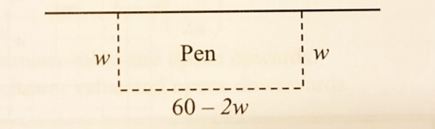
- Mary stands on the top of a building and fires a gun upwards. The bullet travels according to the equation $h\left(t\right)=-16t^{2}+384t+50$, where h is the height of the bullet off the ground in metres at t seconds after it was fired.
a) How high above the ground is Mary holding her gun?
b) How long does it take the bullet to reach its maximum height and what was the maximum height of the bullet?
c) After how many seconds does the bullet hit the ground?
- A cannon is fired from a cliff above the water. The height h (in metres) of the cannon above the water is given by $h\left(x\right)=-0.005x^{2}+x+100$, where x is the horizontal distance of the cannon from the base of the cliff.
a) How many metres above the water is the cliff?
b) How far from the cliff is the cannon shell reaching its maximum height, and what is its maximum height?
c) How far from the base of the cliff will the cannon shell land in the water?
- The length and width of a rectangular sheet of plywood is 4ft. by 8ft. How much must be added equally to the length and width to double the area?
- Determine an equation for each of the following parabolas:
a) b)
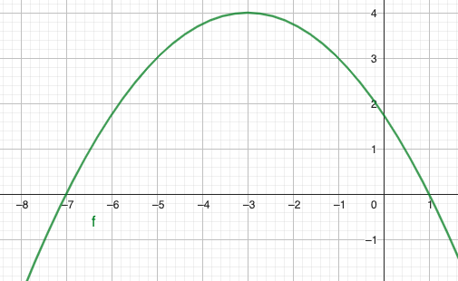 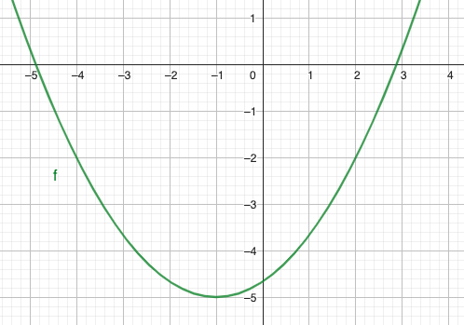
c) d)
