Chapter 5 Review

5.1 Working With Radicals:
1. Convert each entire radical to a mixed radical in simplest form. State any restrictions on the
variable(s).
a) $\sqrt{288}$ b) $\sqrt{{128c}^{2}}$

c) $\sqrt{24a^{4}b^{3}}$ d) $\sqrt[3]{250x^{3}y^{5}}$

2. Convert each mixed radical to an entire radical. State any restriction on the variable(s).
a) $4\sqrt{6}$ = b) -5m$\sqrt{7}$

c) 3y$\sqrt[3]{{2y}^{2}}$ d) $-2x\sqrt[4]{{6xy}^{3}}$

3. Simplify. State any restrictions on the values for the variables.
a) 3$\sqrt{6}-4\sqrt{6 }= ____________\sqrt{6}$ b) $-\sqrt{45 }+2\sqrt{5 }- \sqrt{20}$

c) $-3\sqrt{18 }+3\sqrt{8x }- \sqrt{{32x}^{3}}$ d) $2\sqrt[3]{6x^{2}}y - \sqrt[3]{48x^{2}}y$

4. Put the following values in ascending order: $3\sqrt{30,} \sqrt{250}, 16, 4\sqrt{15}$

5. A wire I pulled taut between two posts. A weight is placed in the middle of the wire, which
pulls the wire down at its centre by 2ft. How long is the wire after the weight is place on it?
Write the answer in simplest radical form.
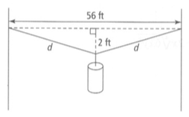

5.2 Multiplying and Dividing Radical Expressions:
6. Multiply. Express each product I simplest form. State any restrictions on the values for the
variables.
a) $(\sqrt{6 })\sqrt{14}$ b) $(\sqrt{3x^{2}})(2\sqrt{3x^{4}}$)

c) $(-10y\sqrt{5 })(4\sqrt{50 })$ d) $(5-4\sqrt{3 })(3+3\sqrt{3 })$

e) $(\sqrt{2 }-3\sqrt{5r })^{2}$ f) $(3-\sqrt{2x })(3+ \sqrt{2x })$

7. Rationalize each denominator. State any restrictions on the values for the variable(s).
a) $\frac{4}{\sqrt{5}}=$ b) $\frac{-\sqrt{2}}{8\sqrt{3}}$

c) $\frac{3}{\sqrt{5}}+4$ d) $\frac{3 + 4\sqrt{3}}{\sqrt{2} + 2\sqrt{5}}$

e) $\frac{\sqrt{15xy}}{\sqrt{10xy^{3}}}$ f) $\frac{3n^{2} + \sqrt{2n^{2}}}{\sqrt{10n}}$

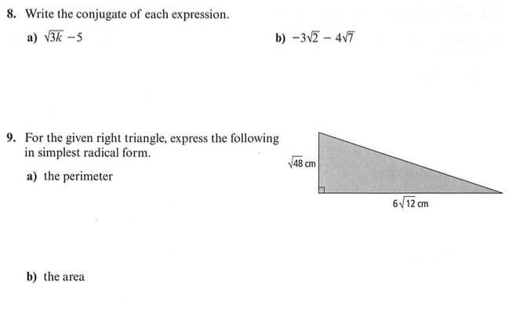

5.3 Radical equations:
10. Solve each radical equation. State any restriction on the variable.
a) $-8+\sqrt{5a-5}=-3$ b) $\sqrt{2n-88}=\sqrt{\frac{n}{6}}$
c) $b-6=\sqrt{18-3b}$ d) $\sqrt{x+4}-\sqrt{x-4}=2$

11. Two adjacent sides of a parallelogram have the measures $\sqrt{14n-45}$ cm and $2n$ cm.
Determine the actual lengths of the two sides if the perimeter of the parallelogram is 54 cm.

12. The Japanese game called Chu Shogi uses a square board. The board is covered with smaller
squares that are alternating black and white. Each of these squares is 3 cm by 3 cm. If the diagonal
of the square playing board is $\sqrt{2592}$ cm, how many small squares are on the board?

Chapter 6 Review
6.1 Rational Expressions:
1. Simplify the following rational expressions. State any non-permissible value of the
variable(s).
a) $\frac{ x^{2} - 10x + 25}{x^{2}-11x + 30}$ b) $\frac{3x^{2} + 15x + 12}{3x^{2} + 12x}$

2. Can the expression $\frac{–x+7}{\left(x-7\right)\left(x+7\right)}$ be simplified further? Explain.

6.2 Multiplying and Dividing Rational Expressions:
3. Determine the product. Express your answer in simplest form. State the non-permissible
values. $\frac{10x^{2 }- 5x}{x^{2} - x - 42} × \frac{x^{2} - 11x + 28}{60x - 15x^{2}}$

4. Write an expression for tan $θ$ based on the information in the diagram below.
Simplify the expression and state any non-permissible values.
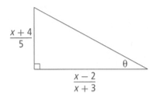

6.3 Adding and Subtracting Rational Expressions:
5. Determine the least common denominator (LCD) for the following set of rational
expressions. Leave your answers in factored form.
$\frac{x + 7}{4x}, \frac{8x}{x^{2 }- 36} , \frac{1}{x^{2 }+ 6x}$

6. Determine each difference. Express each answer in simplest form. State the non-permissible
values of the variable.
a) $\frac{2x^{2} - 7x}{x^{2 }- 100} - \frac{x^{2} - 2x + 10}{x^{2} - 100}$

b) $\frac{2x - 3}{x^{2} + 5x} - \frac{x + 9}{x^{2} - 4x - 5}$

6.4 Rational Equations:
7. Emily can shovel the driveway in 25 min. It takes her younger brother Steve
40 min. If they work together to shovel the driveway, how quickly will they finish?

7. A group of friends go on a 3h bike ride together. They ride 15km with with the wind at their backs, and then 15km straight into the wind. The wind adds or subtracts 3 km/h from their speed. What is the average speed of the group of friends with no wind?

Chapter 5 Review- SOLUTIONS

1. a) 12$\sqrt{2}$ b) 8c$\sqrt{2}$
c) 2a²b$\sqrt{6b}, b≥0$ d) 5xy$\sqrt[3]{{2y}^{2}}$
2. a) $\sqrt{96}$ b) $-\sqrt{175m^{2}}$
c) $-\sqrt[3]{54y^{5}}$ d) $-\sqrt[4]{96x^{5}}y^{3}$
3. a) $-\sqrt{6}$ b) $-3\sqrt{5}$
c) $-9\sqrt{2}+6\sqrt{2x}-4x\sqrt{2x}, x≥0$
d) 0, x is any real number, y is any real number
4. $4\sqrt{15}, \sqrt{250}, 16, 3\sqrt{30}$
5. $4\sqrt{197} ft$
6. a) $2\sqrt{21}$ b) 6x³
c) $-200y\sqrt{10}$ d) $-21+3\sqrt{3}$
e) $2-6\sqrt{10r}+45r,r≥0$ f) $9-2x,x≥0$
7. a) $\frac{4\sqrt{5}}{5}$ b) $\frac{-\sqrt{6}}{24}$ c) $–\frac{(3\sqrt{5}}{11}$
d) $\frac{–(3\sqrt{2}-6\sqrt{5}+4\sqrt{6}-8\sqrt{15}}{18}$
e) $\frac{\sqrt{10}}{2y}, x>0,y>0$
f) $\frac{3n^{2}\sqrt{10n}+n\sqrt{20n}}{10n}$, n > 0
8. a) $\sqrt{3k}+5$ b) $-3\sqrt{2}$ + 4$\sqrt{7}$
9. a) 16$\sqrt{3}+4\sqrt{30} cm$``` b) 72 cm²
10. a) 6, a $≥$ 0 b) 48, n $≥$ 44
11. 9 cm and 18 cm
12. 144 squares
Chapter 6 Review- SOLUTIONS

1. a) $\frac{x-5}{x-6}, x≠5, 6$ b) $\frac{x+1}{x},x≠-4, 0$
2. Yes; by factoring out (-1) from both terms of the
numerator, you can then cancel out (x – 7) in the
numerator and denominator.
3. $\frac{–2x+1}{3x+18},x≠-6, 0, 4, 7$
4. $\frac{x^{2}+7x+12}{5x-10},x≠-3, 2$
5. $4x(x-6)(x+6)$
6. a) $\frac{x-1}{x-10}, x≠±10$
b) $\frac{\left(x+3\right)\left(x+1\right)}{x\left(x+5\right)\left(x-1\right)},x≠-5, 0, 1$
7. 15.4 min

