Chapter 9 – SOLVING INEQUALITIES with 1 VARIABLE

Examples: Solving $3\left(x-5\right)>5x+4$ or $\left(x-3\right)\left(2x+1\right)≤-6$

Solving these inequalities means finding the condition that the variable needs to meet for the inequality to be true…

You can give the solutions in 3 equivalent different ways: as a set of values, on a number line, or as an interval.

I – Linear inequalities with 1 variable (Review)

The method to solve a linear inequality is the same than the one to solve a linear equation:
- Expand to remove the brackets.
- Collect like terms and isolate the ones with the variable.
- Divide both sides of the inequality by the coefficient of the variable in order to isolate the variable.

IMPORTANT: On that last step, you need to pay attention: if you divide both sides by a negative number, you need to “flip” the inequality symbol!! (and that’s the only time you would do it btw…)

Examples:
- $2x-5≤4$
- $3\left(x-5\right)>5x+4$

Reminders on intervals:
- $-3<x≤5$ corresponds to $(-3;5]$
- $x>2$ corresponds to $(2;+∞)$
- $x≤-1$ or $x>5$ corresponds to $\left(-∞;-1\right]∪(5;+∞)$

Note: You can sometimes be asked to test if a value is a solution or not. In that case, you just need to replace the variable by that value separately on both sides of the inequality and see if the inequality symbol works or not…
Example: Is the value of x a solution to the given inequality?
a) x = 4 for $3x-5<2x+1$
b) $x=-3$ for $2x+5<-(x+4)$
Note: This method is good for any type of inequality (linear or quadratic or anything else…)
II – Quadratic inequalities with 1 variable (cf textbook 9.2)

The methods to solve quadratic inequalities with 1 variable are different than the one for linear inequalities. The point isn’t to isolate the variable, but to write all the terms on the same side to compare the quadratic expression to 0…

Example: $\left(x-3\right)\left(2x+1\right)≤-6$ needs to be re-written $2x^{2}-5x+3≤0$.

You will then have to determine the condition on the variable x for your quadratic expression to be positive or negative (negative or zero for the previous example), which means determine the condition on the variable x for the parabola to be above or under the x- axis...

We will work on 2 different methods to determine the sign of the quadratic expression:
- graphically using the zeros
- by sign analysis

- Solving a quadratic inequality with 1 variable graphically:
Example 1: Solve $\left(x-3\right)\left(2x+1\right)≤-6$
Note: the zeros are accepted in the solution…
Example 2: Solve $x^{2}-3x-5>0$
Note: The zeros aren’t accepted in the solution…
Hwk: p 484 # 1 – 3, 7, 9, 10 – 13, 15ab, 17

- Solving a quadratic inequality with 1 variable with sign analysis:
Sign analysis is a method that works for any polynomial expression (not only degree 2) or rational expression that you can factor. The idea is to determine the sign of each of the factors and then use sign rules to determine the sign of the expression.
Example 1: Determine the sign of $x^{2}-x-6$:
First, you factor your expression: $x^{2}-x-6=\left(x-3\right)\left(x+2\right)$
Then, you show the zeros of each factor in a table:
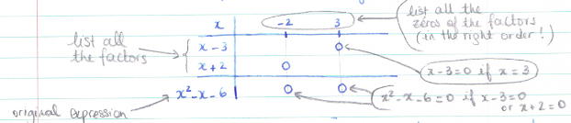 And finally, you fill the table with the signs of each factor and their product…
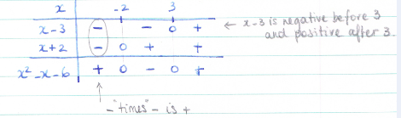
Therefore, $x^{2}-x-6$ is positive if x < -2 or x > 3
and $x^{2}-x-6$ is negative if -2 < x < 3

Your turn: Determine the sign of $2x^{2}-7x-15$.

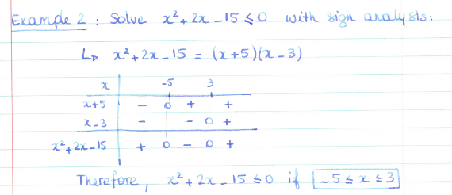
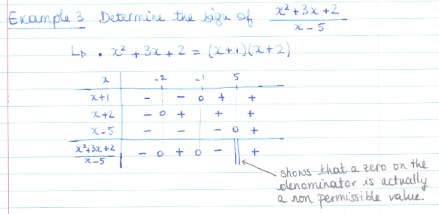
Hwk: p 485 # 5, 8 + hand out

