Chapter – EXPONENTS AND CLASSIFICATION OF NUMBERS

I – Reminder on Exponent Laws:
Product of Powers with the same base:

Example:

Quotient of powers with the same base:

Example:

Power of a power:

Example:

Power of a product:

Example:

Your turn:
a) $3^{2}×3^{5}$ e) ${(4^{2})}^{5}$

b) ${\left(-4\right)}^{7}×{\left(-4\right)}^{6}$ f) ${({\left(-3\right)}^{4})}^{3}$

c) ${\left(-5\right)}^{10}÷{\left(-5\right)}^{8}$ g) ${\left(3x\right)}^{2}$

d) $\frac{2^{12}}{2^{7}}$ h) ${\left(2x^{2}\right)}^{3}$
Hwk: 2 worksheets
II – A few new rules for exponents:

- Rational exponents:

$x^{\frac{1}{n}}=\sqrt[n]{x}$ for any natural number n

Examples: ${16}^{\frac{1}{2}}=$

${(-64)}^{\frac{1}{3}}=$
${\left(\frac{16}{9}\right)}^{\frac{1}{2}}=$

$x^{\frac{n}{m}}={\sqrt[m]{x}}^{n}$ for any natural numbers n and m. n could be 0

Examples: ${16}^{\frac{3}{4}}=$

$\sqrt[3]{25}=$

${0.04}^{\frac{3}{2}}=$

${(-32)}^{0.4}=$

${\left(\sqrt[4]{5^{12}}\right)=}^{}$

- Negative Exponents:
Rule:
$x^{-n}=\frac{1}{x^{n}}$ for any number n. x can’t equal 0.
Examples: $3^{-4}=$
${10}^{-2}=$
$\frac{1}{3^{-2}}=$
$\frac{5^{2}×3^{-4}}{7^{-3}×2^{4}}=$

Be careful: A negative exponent, is not the same than a negative number…
Examples: $3^{-2}$
$3^{-3}$
${\left(-3\right)}^{-2}$
${(-3)}^{-3}$
Generalization of the rule:
${\left(\frac{a}{b}\right)}^{-n}={\left(\frac{b}{a}\right)}^{n}$
Examples: ${\left(\frac{3}{4}\right)}^{-3}=$

$4^{-\frac{1}{2}}=$

${(-27)}^{-\frac{1}{3}}=$
${(-8)}^{-\frac{2}{3}}=$

${1.21}^{-\frac{1}{2}}=$

${\left(\frac{9}{16}\right)}^{-\frac{3}{2}}=$

$\frac{4^{-\frac{1}{2}×}{27}^{-\frac{2}{3}}}{9^{\frac{5}{2}}×8^{\frac{2}{3}}}=$

III – Applying exponent Laws :

- ${0.3}^{-5}×{0.3}^{3}=$
- $\frac{4^{3}×4^{5}}{4^{-2}}=$
- $\left(x^{3}y^{2}\right)×\left(x^{2}y^{-4}\right)=$
- ${\left[{\left(-\frac{3}{2}\right)}^{-4}\right]}^{2}×{\left[{\left(-\frac{3}{2}\right)}^{2}\right]}^{3}=$
- $\frac{10a^{5}b^{3}}{2a^{2}b^{-2}}=$
- ${(8a^{3}b^{6})}^{\frac{1}{3}}=$
- $\left(x^{\frac{3}{2}}y^{2}\right)\left(x^{\frac{1}{2}}y^{-1}\right)=$
- $\frac{4a^{-2}b^{\frac{2}{3}}}{2a^{2}b^{\frac{1}{3}}}=$
- ${\left(\frac{100a}{25a^{5}b^{-\frac{1}{2}}}\right)}^{\frac{1}{2}}=$

IV – Classification of numbers:

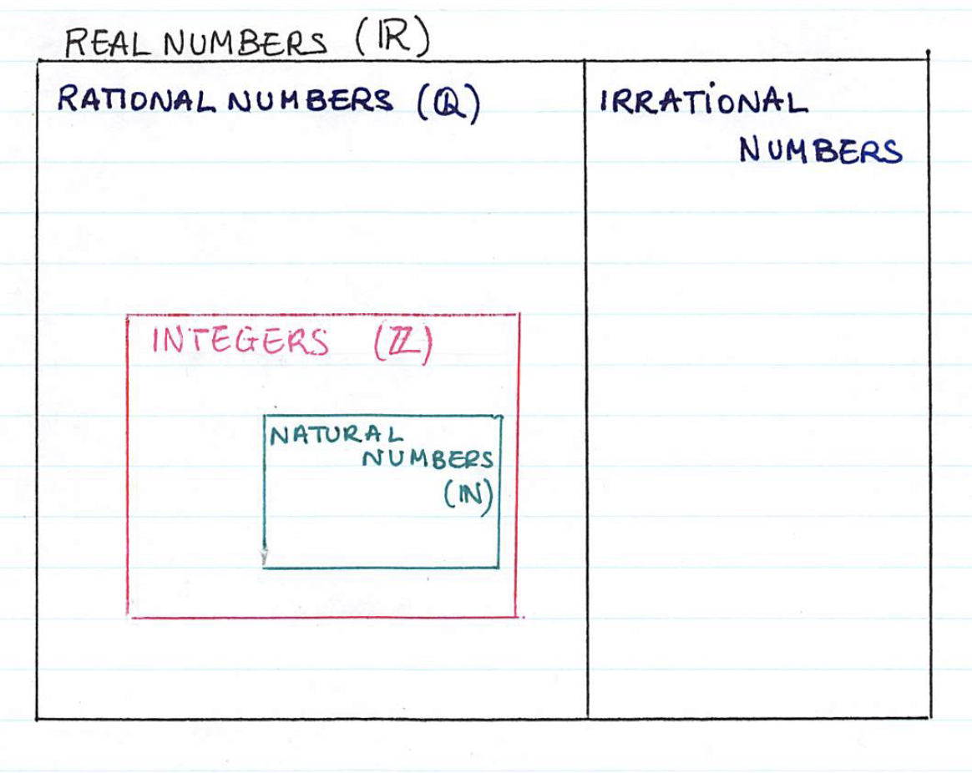

Position the following numbers in the appropriate number set:
$$0 ; 1 ; -3 ; \frac{2}{3} ; π ; \sqrt{25} ; -\frac{12}{4} ; \sqrt{0.09} ; \sqrt{2} ; \sqrt[3]{-8} ; 0.\overline{6} ; \sqrt{12.1}$$

