Functions Review (Math 10)

I – Domain, Range, Functions:
The domain is the set of all the possible values for the independent variable.
The range is the set of all the possible values for the dependent variable on the domain.
Examples :
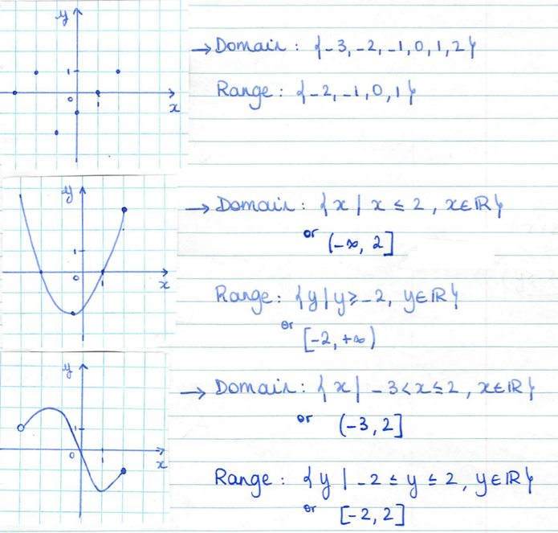
Note :
- When the dots aren’t connected, the domain and range will be a list of values.
- When the dots are connected, the domain (and range most of the times) will be written as an interval or a set of values satisfying a condition.
A relation is a function if each element from the domain is associated with exactly 1 element from the range.

VERTICAL LINE TEST:
To determine if a relation is a function or not given its graph, you need to slide a vertical line across the graph and see if it intersects the graph at more than 1 point at a time or not.
Examples :
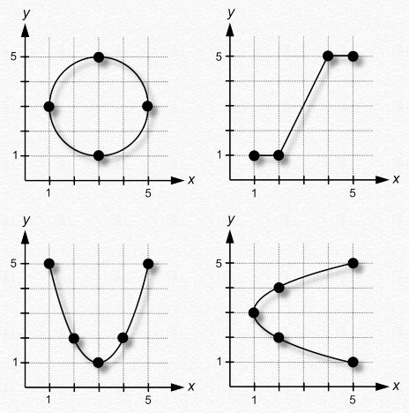
Functional notation indicates which variable the dependent variable depends on…
$A=πr^{2}$ $↔$ $A\left(r\right)=πr^{2}$
equation notation functional notation
$y=2x-5$ $f\left(x\right)=2x-5$

II – Graphs :

In grade 11, you already know how to graph any linear function.

A method to graph other types of functions is to create a table of values and collect enough values to get a good idea of the shape of the graph…
Examples:
a) $y=\sqrt{x}$

Note : You can also create a table of values using your graphing calculator…
The “top” buttons of your graphing calculator are the ones we’ll use to graph functions and solve equations…
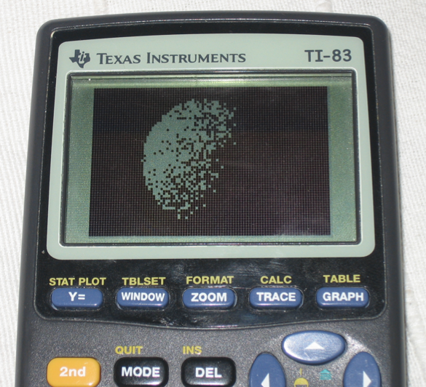

Y= is where you’re going to enter the equation of your function(s)
GRAPH is the button you’ll push after having entered your function in Y= to look at the graph.
TABLE is where you’re going to be able to read a table of values.
TBLSET is where you decide at what value of x you want to start for your table of values and how often you want another value. It can be reached by pushing 2nd and then WINDOW
WINDOW is where you’re going to decide which values of x and y you’re interested in seeing on your graph.
CALC is a button that can help you find different characteristics on your graph… It can be reached by pushing 2nd and then TRACE .

b) $h\left(t\right)=t^{2}+4t+3$
The y-intercept is the point where the graph intersects the y-axis. You can determine it from the graph or algebraically using the equation of the function: It’s the y value for which x = 0.

The x-intercept is the point where the graph intersects the x-axis. You can determine it from the graph or algebraically using the equation of the function: It’s the x value for which y = 0.

Example: a) Determine the intercepts for $y=3x-5$

b) Using technology, determine the intercepts for $y=x^{2}-8x+12$ as well as its minimum.

