Functions Review - worksheet

- Write these solutions as an interval or a set of values.
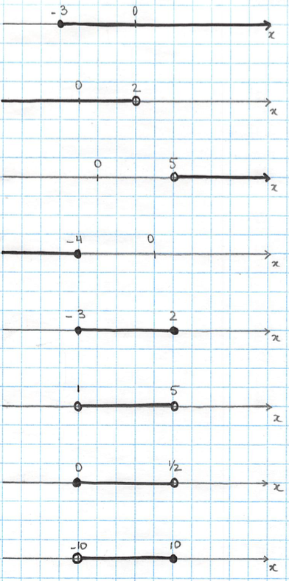
- Write as a set of values
a) $\left[5;10\right]$ b) $[2;3)$
c) $(-3;5]$ d) $(3;∞)$

- Write as an interval.
a) $x<-3$ b) $x≤2$
c) $x>5$ d) $x≥-1$
e) $-3≤x≤5$ f) $1≤x<3$
- $f\left(x\right)=-5x+10$, determine:
a) $f(3)$
b) the value of x for which $f\left(x\right)=-16$.
- Determine what the dependent and independent variables are:
a) Volume of a sphere: $V=\frac{4}{3}πr^{3}$
b) At the theatre, the price paid P and the number of tickets bought n.
- Determine the domain of the following relation: {(8 ;10) ; (5 ;7 ) ; (9 ;-11) ; (6 ;-8)}

- Determine :
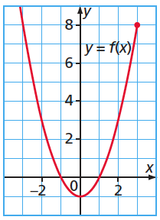
Domain :______________________
Range :_________________________
$f\left(0\right)=$_________ $f(-2)$ = ________
Determine $x$so that $f\left(x\right)=0$: _________
Determine $x$ so that $f\left(x\right)=8$: _________

- Determine Domain, Range and if it’s a function :
a) b)
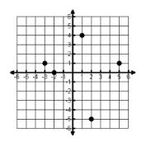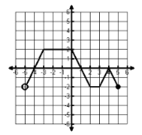
c) d)
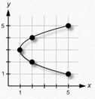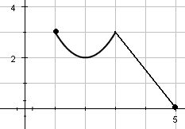

- Fill the tables of values :
a) b)
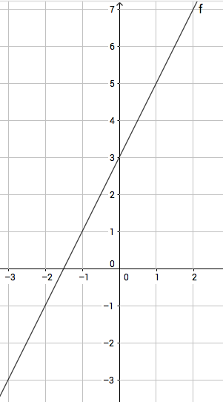 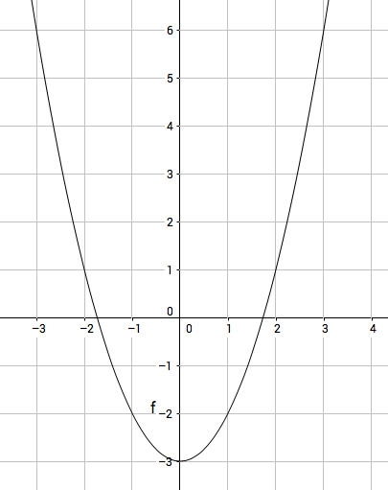

a)
x | -3 | 0 | 1
y |  |  |  | -1

b)
x | -1 | 0
y |  |  | 1 | 6
What are the intercepts ? (determine graphically, and approximate if need be)

- Determine the following values for f:
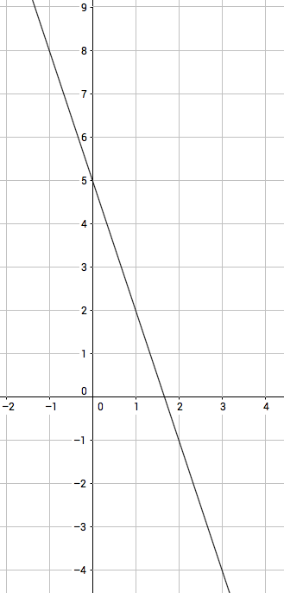
$f\left(0\right)=$ x such that $f\left(x\right)=-2$

$f\left(1\right)=$ x such that $f\left(x\right)=8$
- Determine the following values for f:
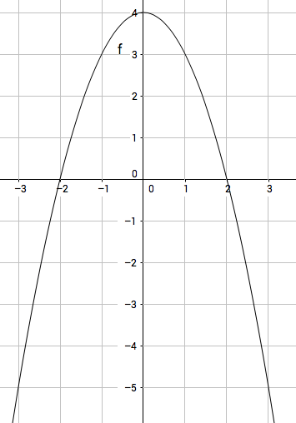

$f\left(0\right)=$ x such that $f\left(x\right)=0$

$f\left(-1\right)=$ x such that $f\left(x\right)=-5$

- Graph the following functions and determine algebraically their intersects:
a) $f\left(x\right)=-4x+5$

b) $y=2\sqrt{x^{2}-9}$

c) $y=x^{2}-2x-8$

