QUIZ 2.1 – 2.2

**CALCULATOR SECTION**

1. Solve the following equations. Give an exact value when possible. If not, round your answer to the nearest tenth. Show your work. [8]  
   a)  for . b) $cosθ=0.2$ for   
     
     
     
     
     
     
     
     
     
     
     
     
     
     
     
     
   c) $\tan{θ}=-\sqrt{3}$ for . d) $\sin{θ}=-\frac{1}{3}$ for 

QUIZ 2.1 – 2.2

**NO CALCULATOR SECTION**

1. What is the reference angle for a 156° angle in standard position? [1]
2. What angles in standard position correspond to a 30° reference angle? [2]
3. Determine cos α, sin α and tan α where α is an angle in standard position whose terminal arm passes through A(4,-3). [3]

1. Determine cos α and sin α, knowing that the terminal arm of angle α is in quadrant III and tan α = $\frac{5}{3}$. [2]

1. Fill in the blanks with the angles in the boxes as well as the exact values of the ratios in the table. [4]  
   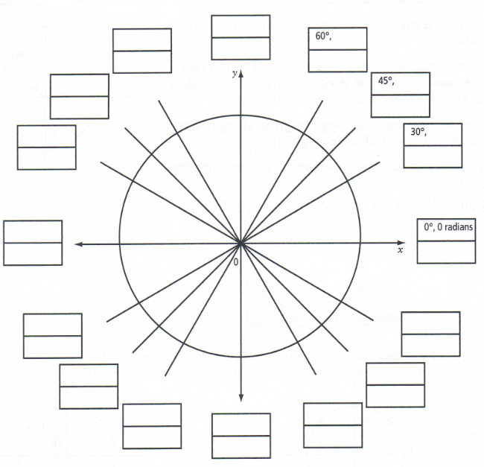

|  |  |  |  |  |  |  |  |  |  |  |  |  |
| --- | --- | --- | --- | --- | --- | --- | --- | --- | --- | --- | --- | --- |
| θ | 0**°** | 30**°** | 45**°** | 60**°** | 90**°** | 150**°** | 180**°** | 225**°** | 270**°** | 300**°** | 315**°** | 330**°** |
| cos θ |  |  |  |  |  |  |  |  |  |  |  |  |
| sinθ |  |  |  |  |  |  |  |  |  |  |  |  |
| tan θ |  |  |  |  |  |  |  |  |  |  |  |  |