QUIZ Chapter 3 Part II

- Fill the following table:
Quadratic function | $$y=3{\left(x-4\right)}^{2}+5$$ |  |  |  | $$y=-2{\left(x+1\right)}^{2}+4$$
Orientation

Axis of symmetry

Vertex

Number of zeros

y-intercept

Table of values | x | 5 | 6 | 7 | x | 0 | 1 | 2
 | y |  |  |  | y

- Graph $y=-2{\left(x-3\right)}^{2}+5$ and show your work.

- Determine the equation of the following function:
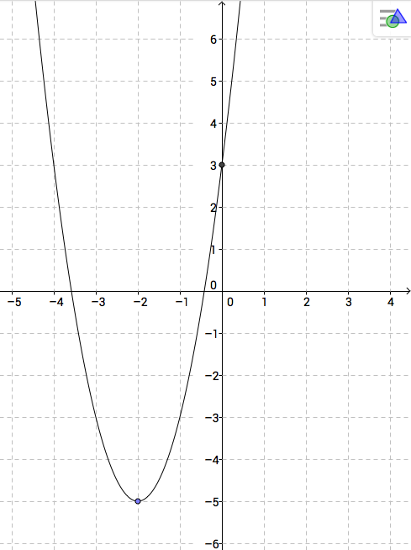

- Determine the number of x-intercepts of the following functions. Explain your reasoning.
a) $y=3{\left(x+4\right)}^{2}-5$
a) $y=-2{\left(x+3\right)}^{2}-7$
a) $y={\left(x-1\right)}^{2}$

