Chapter 2 Review- SOLUTIONS

1. a) I, $θ$_{R} = 35$°$
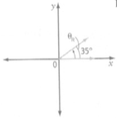
b) II, $θ$_{R} = 15$°$
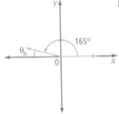
c) III, $θ$_{R} = 36$°$
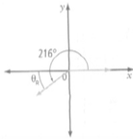
2. a) $-$1` b) $\frac{1}{\sqrt{3}}$
c) $-\frac{1}{\sqrt{2}}$
3. sin$θ$= $\frac{5}{\sqrt{41}}$, cos $θ$ = $-$ $\frac{4}{\sqrt{41}}$, tan $θ$ = - $\frac{5}{4}$
4. cos $θ$ = - $\frac{8}{17}$, tan $θ$ = - $\frac{15}{8}$
5. a) 54$°$, 306$°$ b) 300$°$, 240$°$
6. a) 19$°$ b) 205
7. a) 0 triangles b) 2 triangles
8. a) 13.4 b) 27$°$

Chapter 3 Review- SOLUTIONS

1. a) two x-intercepts, x = -5, domain {x | x $ϵ$ R},
range {y | y $≤$ 6, y $ϵ$ R}
b) one x-intercept, x = 8, domain {x | x $ϵ$ R},
range {y | y $≥$ 0, y $ϵ$ R}
2. a) (3, -7); maximum value is -7
b) (-11, 8); minimum value isb8
3. a) b)
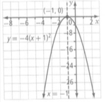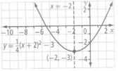
4. a) y = -$\frac{5}{16}$x² b) y = -$\frac{5}{16}$(x – 4)² + 5
c) Answers may vary. Example: The value of a is
the same but the values of p and q change.
5. a) (-4, 0), (2, 0), (0, -8)
b) (-9, 0), (-1, 0), (0, 9)
6. a) -$\frac{3}{2}$ b) -$\frac{5}{6}$
7. a) x = -5, opens downward
b) x = $\frac{2}{3}$, opens upward
8. a) y = (x + 3)² + 6, domain {x | x $ϵ$ R},
range {y | y $≥$ 6, y $ϵ$ R}
b) y = -3(x + 6)² + 8, domain {x | x$ϵ$ R},
range {y | y $≤$ 8, y $ϵ$ R}
c) y = 2(x – 4)² – 10, domain {x | x $ϵ$ R},
range {y | y $≥$ -10, y $ϵ$ R}
d) y = $\frac{1}{2}$(x – 1)² + $\frac{5}{2}$, domain {x | x $ϵ$ R},
range $\left\{y | y ≥ \frac{5}{2}, y ϵ R\right\}$
9. a) (10, 105)
b) The maximum profit of $105 occurs on the 10th
day of sales.
10. a) r = (10 + v)(120 – 5v)
b) The maximum revenue of $1445 occurs at a price
of $17
Chapter 4 Review- SOLUTIONS

1. a) -1.5 b) 3
2. a) Example: The location of the vertex and the
direction of opening determine the number
of zeros for the quadratic function. In this
case, the graph would intersect the x-axis in
two places.
b) Example: The location of the vertex is on the
x-axis.
c) Example: The minimum is above the x-axis, or
the maximum is below the x-axis, meaning that
the graph does not intersect the x-axis.
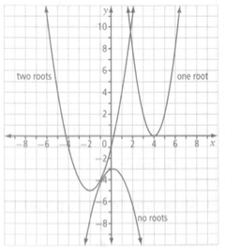
3. a) 2.8, 7.2 b) 8.6, 13.4

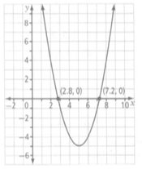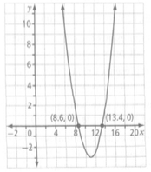

c) 0.1, 3.1
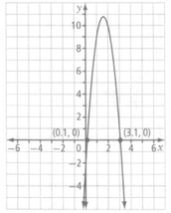
4. a) (a – 7b + 68)(a + 7b – 58)
b) (x + 3)(x – 5) c) $\left(\frac{3m}{4}+ \frac{10n}{9}\right)\left(\frac{3m}{4}- \frac{10n}{9}\right)$
5. a) -4, -2 b) $\frac{2}{3}, 1$
c) $\frac{3}{2}$, $\frac{9}{2}$ d) $-\frac{3}{2}, \frac{3}{2}$
6. 9 in. by 12 in.
7. a) $±$13 b) -18, 4
c) $-4\sqrt{5}+12, 4\sqrt{5}+12$ d) $-5, 3$
8. a) $-\sqrt{23}-4, \sqrt{23}-4; -8.8, 0.8$
b) $-3\sqrt{2}+5, 3\sqrt{2}+5;0.8, 9.2$
9. 30th day
10. a) 2 roots b) 2 roots
c) 1 root d) 0 roots
11. a) $5-\sqrt{15}, 5+\sqrt{15}$; 1.1, 8.9
b) $\frac{–1+\sqrt{41}}{5}, \frac{-1-\sqrt{41}}{5}; -1.5, 1.1$
12. a) -7, 3 b) $-\frac{2}{5}$, 3
b) $\frac{–9+ \sqrt{57}}{4}, \frac{-9- \sqrt{57}}{4}$

