3.2 – THE REMAINDER THEOREM

To divide polynomials, you can use long division or synthetic division.

Examples of LONG DIVISION:
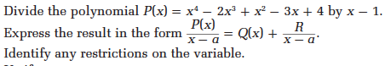

- $\frac{5x^{3}-13x^{2}+10x-9}{x-2}$
- $\frac{x^{3}+2x^{2}-5x-6}{x+1}$
Your turn p 121

Examples of SYNTHETIC DIVISION:

- $\frac{5x^{3}-13x^{2}+10x-9}{x-2}$
- $\frac{2x^{3}+3x^{2}-4x+15}{x+3}$
- $\frac{4x^{3}-5x+1}{x-2}$
Your turn p 122:
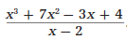

If you divide a Polynomial $P(x)$ by $(x-a)$, then the remainder is $P(a)$.
The REMAINDER THEOREM:
Example 1: $P\left(x\right)=5x^{3}-13x^{2}+10x-9$ divided by $x-2$

Example 2: $P\left(x\right)=2x^{3}+3x^{2}-4x+15$ divided by $x+3$

Your turn: $\frac{x^{3}+2x^{2}-5x-6}{x-2}$ and $\frac{x^{3}-10x+6}{x+4}$

Hwk: p 124 # 3 – 15 + 16

