3.3 – THE FACTOR THEOREM

FACTOR THEOREM
$P\left(x\right)$ can be factored by $(x-a)$ if and only if $P\left(a\right)=0$

Indeed : if $P\left(a\right)=0$, then the remainder is 0, therefore $\frac{P(x)}{x-a}=Q(x)$ or $P\left(x\right)=\left(x-a\right)Q(x)$.

Example : $P\left(x\right)=x^{3}-x^{2}-5x+2$
$P\left(-2\right)=$

Example 1 p 128
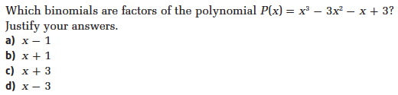

Your turn p 128
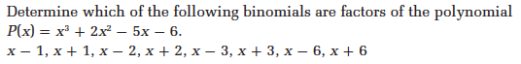

INTEGRAL ZERO THEOREM
If $P(x)$ can be factored by $(x-a)$ [$a$ being an integer], then its constant term can be divided by $a$.

This theorem tells us that if we’re looking for potential factors, we should look at the constant term, and see by what it can be divided. These will be the only potential a values to be considered.

Example: $P\left(x\right)=2x^{3}-5x^{2}-4x+3$

Note: When the constant term can be divided by many integers, it can be very time consuming to evaluate the polynomial by each of them. We can use the table of our graphing calculator to save time (when allowed…)

Example: Factor $x^{4}-5x^{3}+2x^{2}+20x-24$

Your turn p 131:

Hwk: p 133 # 1, 2ab, 3ab, 4ab, 5 – 11, 14 – 16.

