3.4 – EQUATIONS AND GRAPHS OF POLYNOMIAL FUNCTIONS

Sometimes a polynomial has a factor $(x-a)$ repeated several times.
Example: $P\left(x\right)={\left(x-3\right)}^{2}(x+1)$
The number of times the factor $(x-a)$ is repeated is called the multiplicity of the zero $x=a$.

Example: $P\left(x\right)={\left(x-3\right)}^{2}(x+1)$ has a zero multiplicity 2 at $x=3$ and a zero multiplicity 1 at $x=-1$.

Effect on a graph:
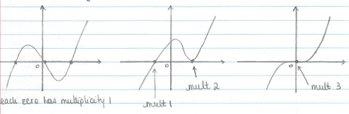

Note: When the multiplicity is odd, the sign of the function changes there.
When the multiplicity is even, it doesn’t.

Getting Info from a graph:

Example 1 p 138
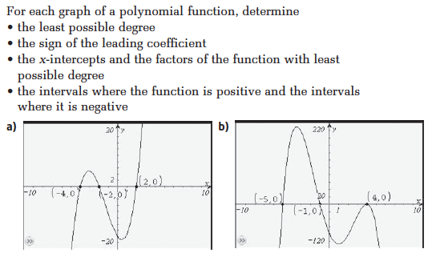

Your turn p 139
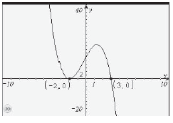

Getting Info from Equations:

Example 2 p 140
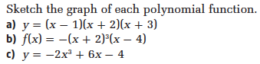

a) b) c)

Your turn p 142
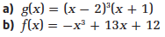

Hwk: p 147 # 1 – 10, 12 – 16.

