4.1 – ANGLES AND ANGLE MEASURE

Definition: 1 radian is the measure of the central angle subtended by an arc equal in length to the radius of the circle.
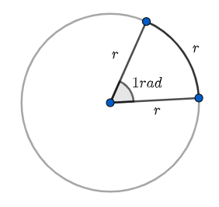
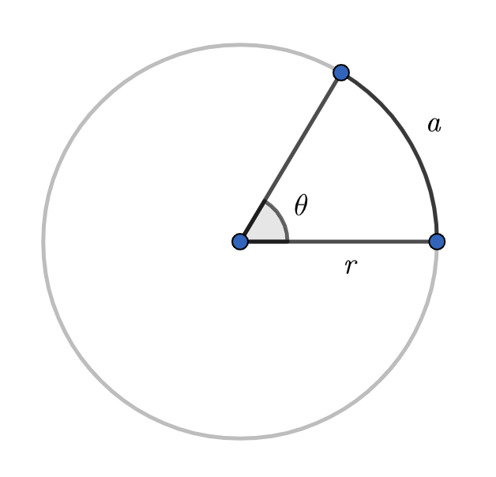

Arc length of a circle:
If the angle is expressed in radians, we get: $a=rθ$

Your turn p 174 ( answers: a) $a≈11.4$, b) $r≈2.6$, c) $θ=\frac{13}{5}$ )
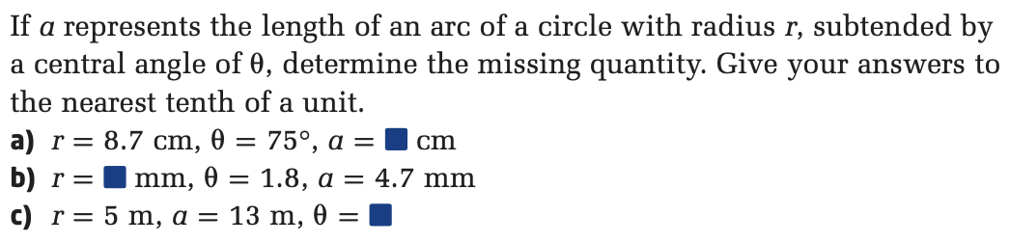
Note, if the circle has radius 1 (unit circle), then the angle in radians and the arc length have the same value.

Conversions to know by heart:
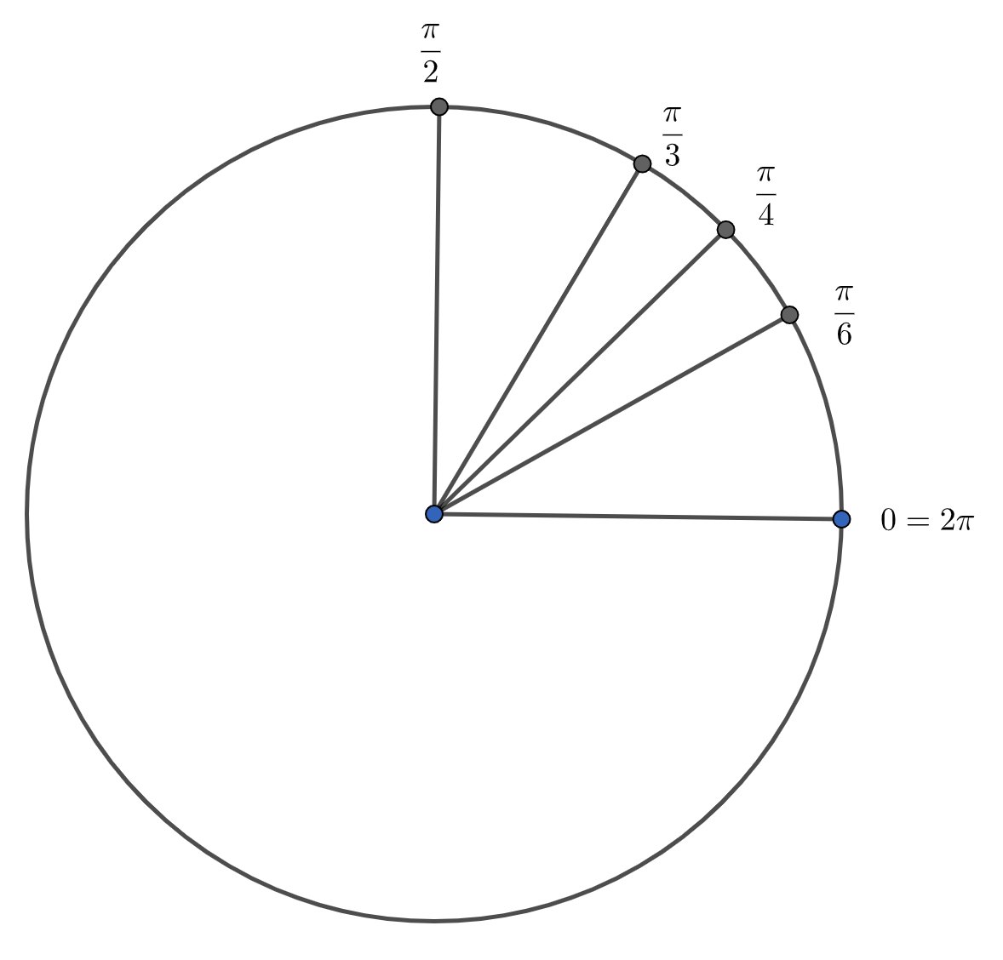

Degrees | Radians
360º | $$2π$$
180º | $$π$$
90º | $$\frac{π}{2}$$
60º | $$\frac{π}{3}$$
45º | $$\frac{π}{4}$$
30º | $$\frac{π}{6}$$

Conversions:
To convert from radians to degrees or from degrees to radians, we can always use cross multiplication with the reference 180º $π$.
But some conversions can be deducted from recognizing the special angles multiples…

Examples:
a) 50º c) $-{213}^{o}$
b) $\frac{π}{9}$ d) 3.2
e) 120º g) $\frac{5π}{4}$
f) -150º h) $-\frac{11π}{6}$

Your turn p 169

When 2 angles in standard position have the same terminal arm, we call them coterminal angles.
They differ by full rotations (360º or $2π$ or their multiples depending on the unit used).

Examples: 30º and 750º are coterminal angles
$\frac{π}{3}$ and $\frac{7π}{3}$ are coterminal angles

Example 2 p 170
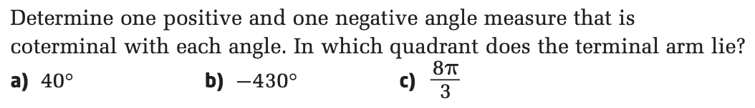

Your turn p 171
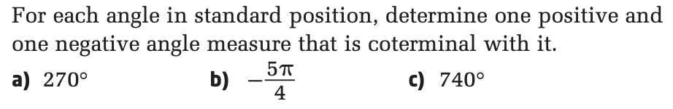
For any angle $θ$, there is an infinity of coterminal angles. When asked for all of them, we give their general form:
$θ+360n, n∈Z$ in degrees or $θ+2πn, n∈Z$ in radians

Example 3 p 172
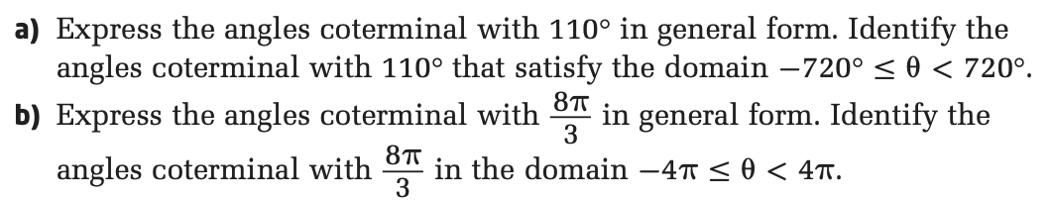

Hwk: p 175 # 2 – 4, 6 – 11, 13 – 16, …

