4.2 – THE UNIT CIRCLE

The equation of a circle with centre $(a,b)$ and radius $r$ is: ${(x-a)}^{2}+{(y-b)}^{2}=r^{2}$

Examples:
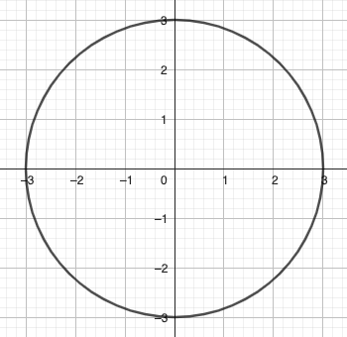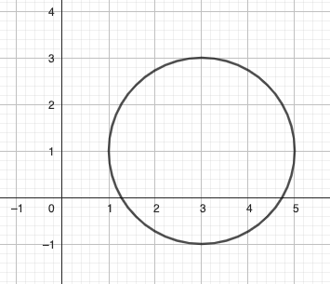

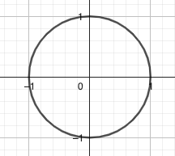

The unit circle is the circle with centre (0,0) and radius 1.

Its equation is: $x^{2}+y^{2}=1$

Applications:
- Prove that $P\left(\frac{\sqrt{5}}{3},-\frac{2}{3}\right)$ is on the unit circle.
- $A(\frac{1}{3}y)$ is on the unit circle. Determine the possible values of $y$.
The unit circle is a useful tool, because for any angle in standard position, the angle and the arc length subtended by the angle have the same value. But more importantly, we can notice that if a point is on the unit circle, its coordinates are $\left(\cos{θ},\sin{θ}\right)$, where $θ$ is the angle in standard position that locates the point on the circle.
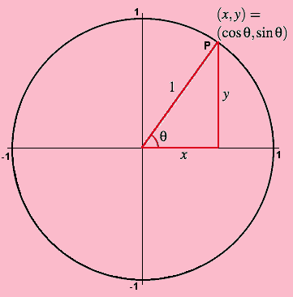

Remembering the “special” values learned in Precalc 11, we get the coordinates of the special points of the unit circle…
We also need to remember the tangent values that we can get back using the equation: $\tan{θ}=\frac{\sin{θ}}{\cos{θ}}$

The special “couples” for sin and cos were: $(0,1)$ $(\frac{\sqrt{3}}{2},\frac{1}{2})$ $(\frac{\sqrt{2}}{2},\frac{\sqrt{2}}{2})$ and vice versa.

The special values for tan were: 0 or undef $\frac{1}{\sqrt{3}}$ or $\sqrt{3}$ $1$

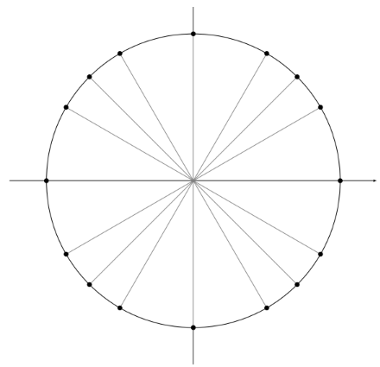
Hwk: p 186 # 1 – 7, 9, 10, 12, 13, 17, 19

