4.3 – TRIGONOMETRIC RATIOS

I – 6 Trigonometric Ratios:

Primary Ratios: $\cos{θ}=\frac{adj θ_{R}}{hyp}$ $\sin{θ}=\frac{opp θ_{R}}{hyp}$ $\tan{θ}=\frac{opp θ_{R}}{adj θ_{R}}=\frac{\sin{θ}}{\cos{θ}}$

Reciprocal Ratios: $\sec{θ=\frac{1}{\cos{θ}}}$ $\csc{θ=\frac{1}{\sin{θ}}}$ $\cot{θ=\frac{\cos{θ}}{\sin{θ}}=\frac{1}{\tan{θ}}}$

Examples:
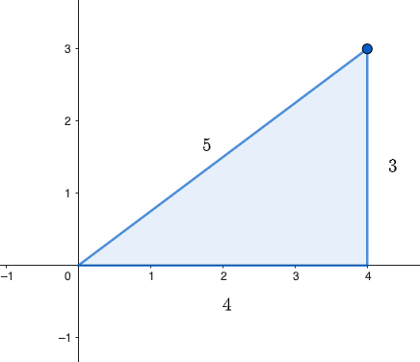

Remember:

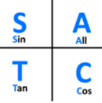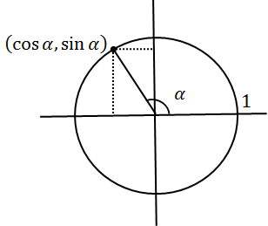

II – Determining a trigonometric ratio given the angle:

If the angle is a “special” angle $\left(\frac{π}{6},\frac{π}{4},\frac{π}{3},\frac{π}{2} and their multiples\right)$

You are expected to give exact values.

Examples: Determine the following ratios:

- $\sin{\frac{π}{3}}$
- $\cos{\frac{3π}{4}}$
- $\tan{\frac{π}{6}}$
- $\tan{{270}^{o}}$
- $\sec{\frac{5π}{6}}$
- $\csc{(-\frac{4π}{3})}$
- $\cot{{315}^{o}}$
Your turn p 195

If the angle is not “special”

You will just use your calculator to get the value of the ratios, but the values won’t be exact.
Be careful to make sure the mode of the calculator matches the unit used…

Examples:

- $cos {200}^{o}$ c) $\sec{{130}^{o}}$
- $\tan{3}$
III – Determining a trigonometric ratio given the coordinates of a point on its terminal arm:

Example: A(-4,3) is on the terminal arm of an angle $θ$ in standard position.
Determine the 6 trig ratios of that angle.

IV – Determining a trigonometric ratio given another ratio:

Example: $θ$ is in quadrant III and $\cos{θ}=-\frac{1}{3}$. Determine $\sin{θ}$ and $\tan{θ}$.

V – Determining an angle given a trig ratio:
Reminder:
$0 ; ±\frac{1}{2} ; ±\frac{1}{\sqrt{2}} ; ±\frac{\sqrt{2}}{2} ; ±\frac{\sqrt{3}}{2} ; ±1$
Special values for sin and cos:
Special values for tan:
$$0 ; ±\sqrt{3} ; ±\frac{1}{\sqrt{3}} ; ±\frac{\sqrt{3}}{3} ; ±1 ;undef$$
For these values, we expect exact angles.
Examples:
- Solve $\cos{θ}= -\frac{1}{2}$ for $0≤θ≤2π$.
- Solve $\sin{θ}= 0$ for $0≤θ≤2π$.
- Solve $\cos{θ}= \frac{1}{3}$ for $0≤θ≤2π$.
- Solve $\sin{θ}= -\frac{3}{4}$ for $0≤θ≤2π$.
- Solve $\tan{θ}= -\sqrt{3}$ for $0≤θ≤2π$.
- Solve $\tan{θ}= 0.2$ for $0≤θ≤2π$.
- Solve $\sec{θ}= 2$ for $0≤θ≤2π$.

NOTE: The values of $\cos{θ}$ and $\cos{θ}$ can only be between -1 and 1 included.
Therefore an equation like $\cos{θ}= 2$ has no solution!

Hwk: p 201 # 1 – 17, 19 – 21.

