5.1 – GRAPHING SINE AND COSINE FUNCTIONS

The graphs of $y=cos x$ and $y = sin x$ look a lot alike.
They are both sinusoidal curves with a period $2π$.

Sinusoidal means that the curve oscillates repeatedly up and down from a centre line.
A period is the number of units every which the graph repeats itself exactly.

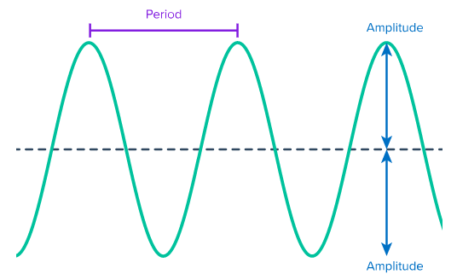

I – Graph of $y=\sin{x}$.
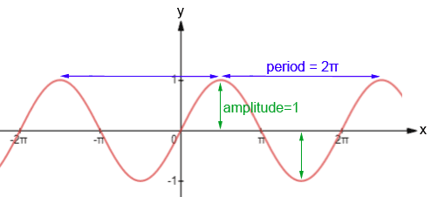
To reproduce this graph, you need to learn the characteristics of the graph over 1 period :

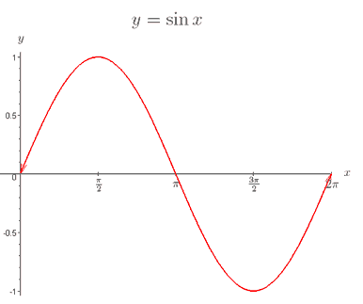
Max : $1$ Min : $-1$
Amplitude :$1$
Period $2π$ or ${360}^{o}$
$y-$intercept : $0$
$x-$intercepts : $0, π, 2π$ (on the cycle showed)
Domain : $R$ Range : $\left[-1,1\right]$

II – Graph of $y=\cos{x}$.
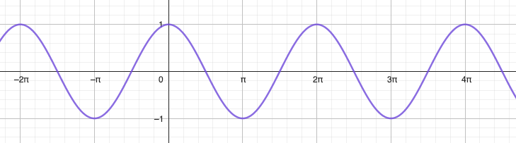
To reproduce this graph, you need to learn the characteristics of the graph over 1 period:
Max : $1$ Min : $-1$
Amplitude :$1$
Period $2π$ or ${360}^{o}$
$y-$intercept : $1$
$x-$intercepts : $\frac{π}{2},\frac{3π}{2}$ (on the cycle showed)
Domain : $R$ Range : $\left[-1,1\right]$

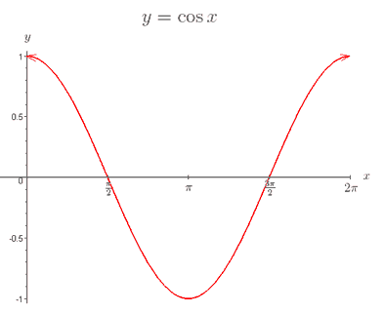

The two graphs are very similar. One is a horizontal translation of the other one.

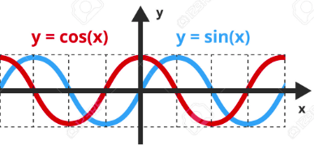

Hwk: p 233 # 1 – 11, 14, 15, 17, 20, 22 – 24.

