5.2 – TRANSFORMATIONS OF SINUSOIDAL FUNCTIONS

$$y=a\sin\left(b(x-h)\right)+k$$

Examples:
Nothing changed except the centre line which is $y=3$.
Amplitude : $\left|a\right|$
Nothing changed except the amplitude which is now 3.
- $y=3\cos{x}$
Note: If $a$ was negative, there would also be a reflection around the centre line (the graph would “start” at a minimum).
- $y=\sin{x+3}$
Centre line : $y=k$
- $y=\cos{(3x)}$
Note: in each cycle, there are 4 easy points to plot (equidistant from one another): 1 max, 1 min and 2 x-intercepts. So, by dividing the period by 4, we know how “often” we are going to plot a point. That helps choosing our scale on the x-axis. In this example, dividing the period by 4 gives us $\frac{π}{6}$. That’s how often we plotted a point.
Nothing changed except the period which is now $\frac{2π}{3}$.
Period : $\frac{2π}{\left|b\right|}$ or ${\frac{360}{\left|b\right|}}^{o}$
- $y=\sin\left(x-\frac{π}{3}\right)$
Phase Shift : $h$
The graph is shifted $\frac{π}{3}$ units to the right. We call it the Phase Shift.
Note: We need to choose our scale on the x-axis so that the phase shift (starting point from our cycle) is easy to plot. So, we need something in common with the 4 easy points previously considered. In radians a common denominator will be the easiest.
Example: $y=\cos{3\left(x-\frac{π}{4}\right)}$

Combining all the transformations:
- $y=-2\cos\left(x+π\right)-1$
- $y=3\sin\left(2x-\frac{2π}{3}\right)+2$

Determining an equation from a graph:

Example:
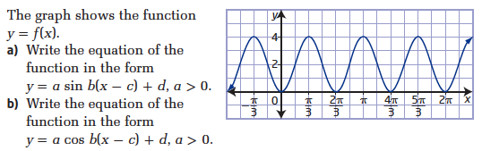

You can usually choose between a cos or a sin curve. The easiest is usually to pick the one that doesn’t involve a phase shift…
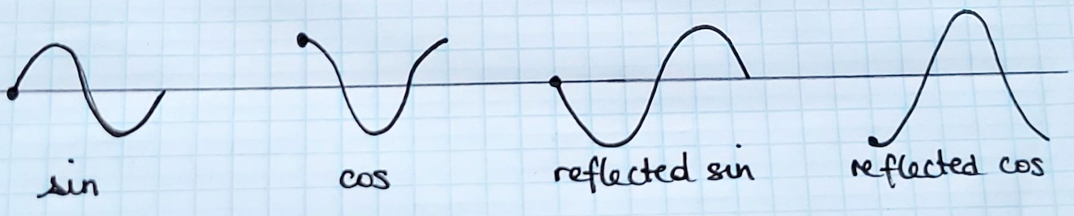

Your turn
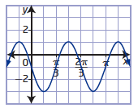

Hwk: p 250 # 1acef, 2acf, 3, 5 – 7, 9, 13 – 17, 22, 24.

