5.4 – Equations and Graphs of Trigonometric Functions

I – Solving Trigonometric Equations

- Graphically
Example 1 : Solve $2\sin\left(\frac{π}{3}\left(x-1\right)\right)+4=3$ for $x ∈[0;10]$
You need to graph (by hand or with your graphing calculator) both sides of the equation : $y=2\sin\left(\frac{π}{3}\left(x-1\right)\right)+4$ and $y=3$ and look for the x coordinates of the points of intersection on the domain.
Note 1 : If you use our graphing calculator, don’t forget to choose the window to match the domain and range, and use the proper mode (Degrees or Radians).
Note 2 : This method is time consuming and will not give exact values if the solutions are not easy to read…
- Algebraically
Example 2 : Solve $2\sin\left(\frac{π}{3}\left(x-1\right)\right)+4=3$ for $x ∈[0;10]$
Treat the argument of the trig function as an angle (you can name it $θ$)
Solve the more basic equation and find all the solutions for 1 period.
Then solve for x for each solution and get all the solutions using the transformed period.
Example 3 : $4\cos^{2}\left(2\left(x-\frac{π}{4}\right)\right)=3$ for $x ∈[0,2π]$
Example 4 : Solve $6\cos\left(\frac{π}{6}x\right)+14=16$ for $x ∈[0;20]$

Your turn : a) $\tan\left(π\left(x-2\right)\right)=-1$ for $x ∈[0;5]$
b) $12\cos\left(2x-{90}^{o}\right)+8=10$ for $x ∈[0;500]$
solutions : a) {2.35, 9.65, 14.35}
b) {4.8º, 85.2º, 184.8º, 265.2º, 364.8º, 445.2º}

II – Modeling a Real-Life situation with a Trigonometric Equation

Many periodic phenomena can be modeled by trigonometric functions.
In 5.3, we’ve seen that shadows, rotating lights, … can often be modeled by the tangent function.
Most problems involving waves, heartbeat, circular motion, … can be modeled with the sine or cosine function.

From the information in the word problem, you need to determine the period (the time it takes for a full cycle to happen), the min and the max values (which will give you the centre line and the amplitude) as well as when the first cycle starts (which will give you the phase shift).
From there you can determine the coefficients a, b, h and k of your function.

TIP : It’s usually your choice to use a sin or cos function. It’s usually a good idea to choose, when possible, the one that doesn’t give a phase shift…
If it starts at a max or a min, choose a cos function.
If it starts on the centre line, choose a sin function.
$y=cos x$ $y=sin x$ $y=-cos x$ $y=-sin x$
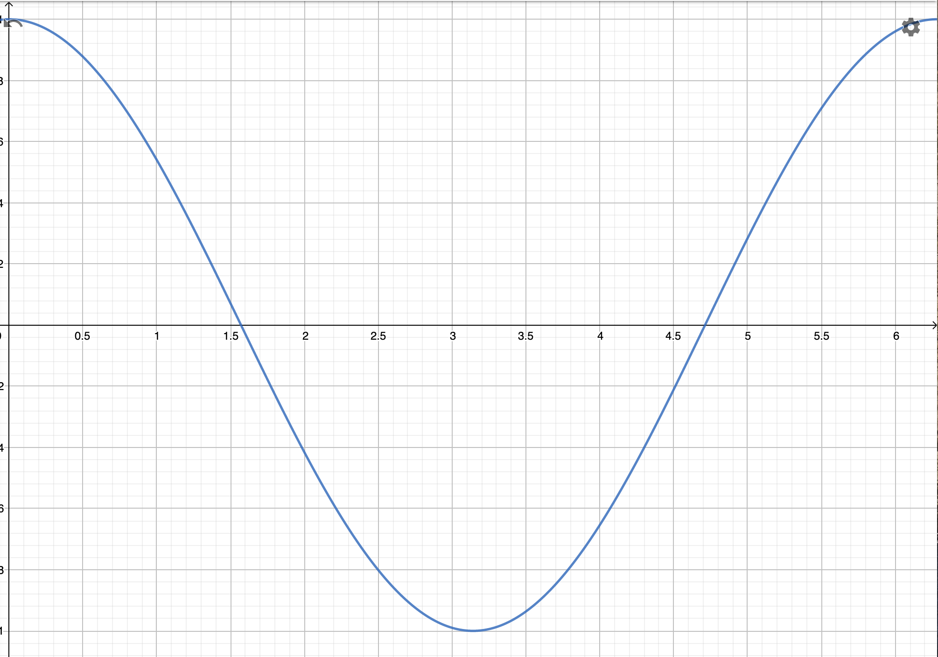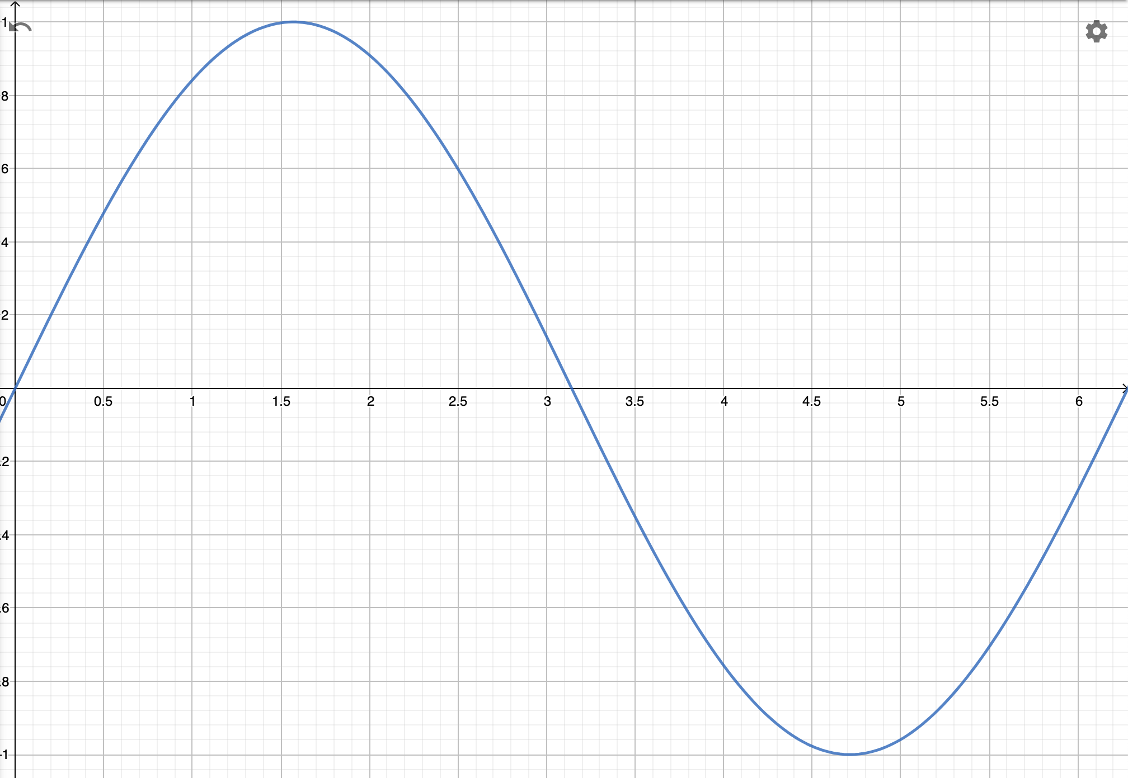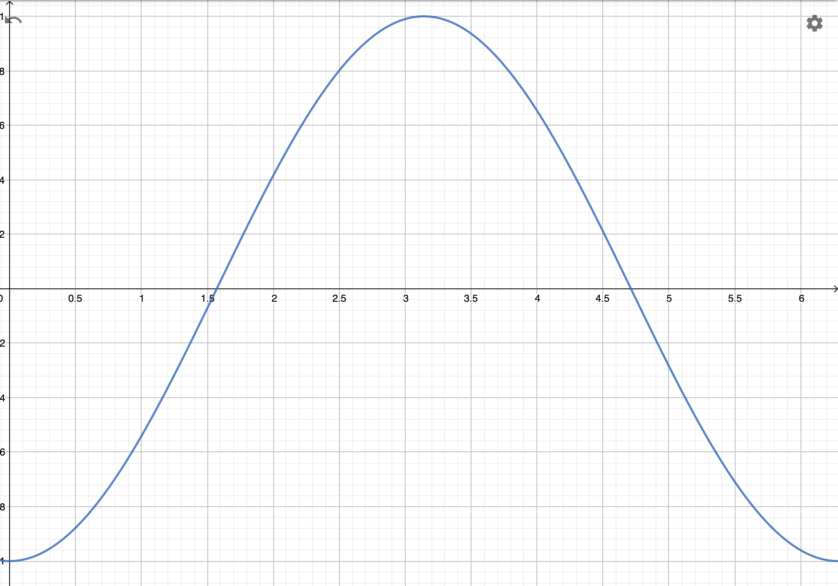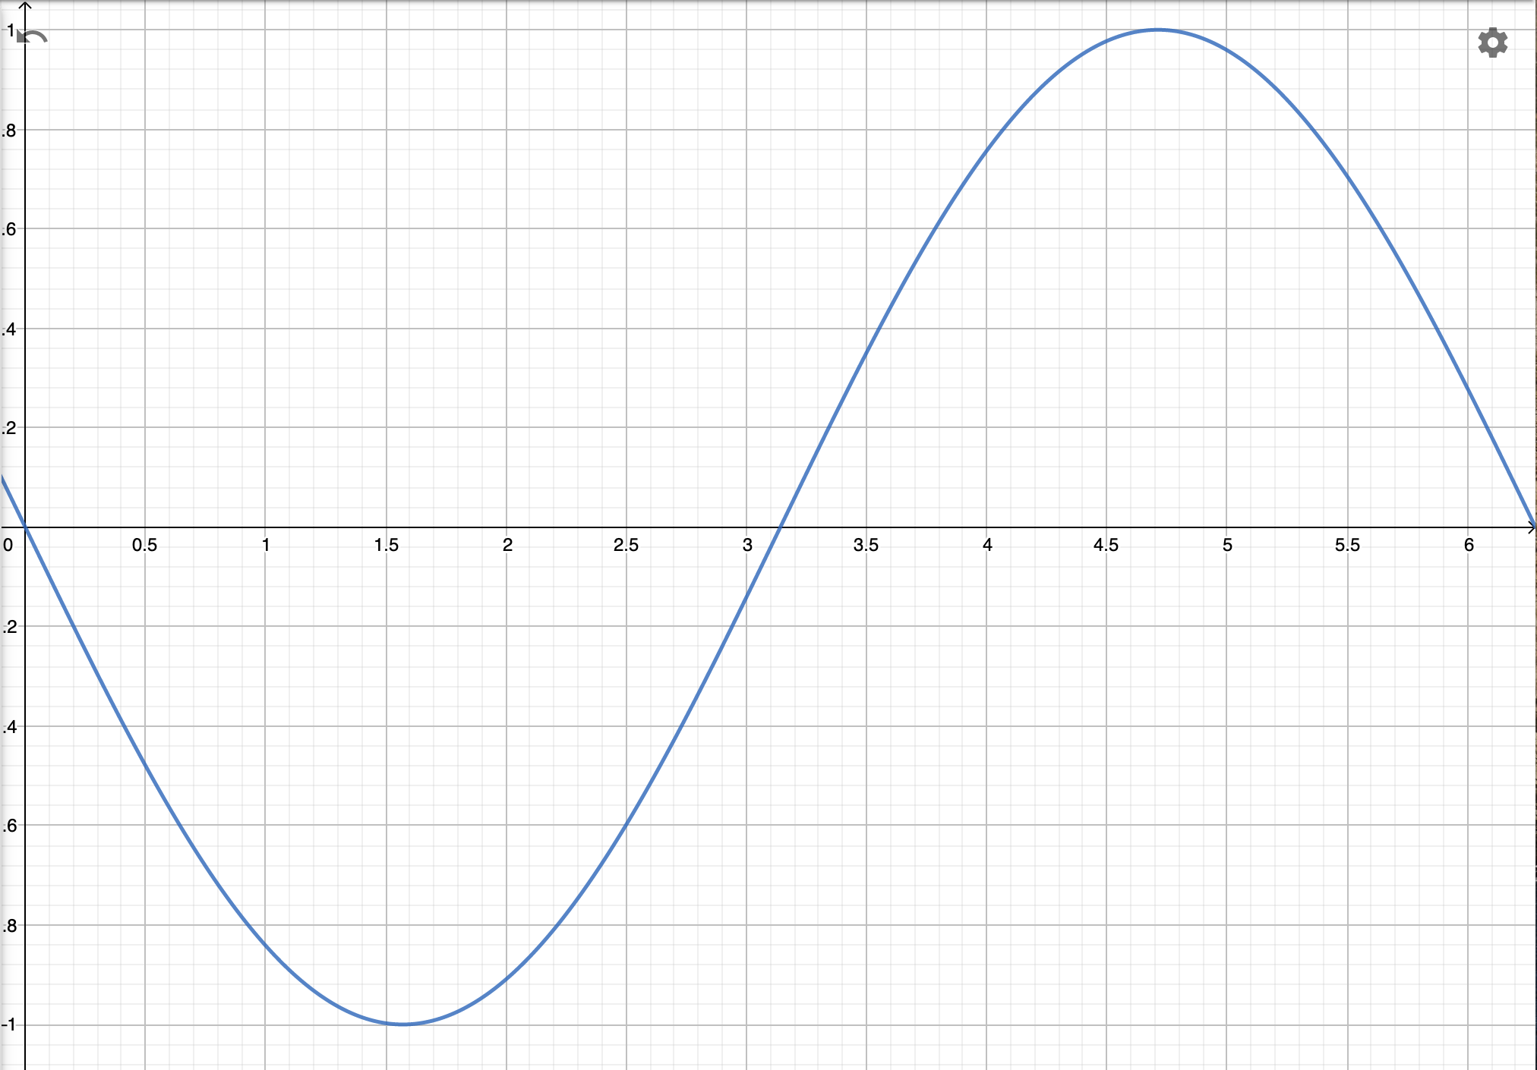

Example: You’re boarding a Ferris wheel at the bottom. The height of the Ferris Wheel is 135m, but the diameter of the wheel is 122m. The Wheel makes 2 rotations per hour (It’s a sight-seeing one).
- Model the height of a passenger as a function of time.
- For how long is the passenger going to stay above 130m in order to see his house during the first rotation?

Hwk: p 275 # 3-6, 9, 10, 15-20.

