Chapter 9 – Rational Expressions - Characteristics

I - Definitions

A rational expression is an expression that can be written as a fraction where both its numerator and denominator are polynomials.

Examples: $f\left(x\right)=\frac{3x-5}{x^{2}-9}$, $g\left(x\right)= \frac{5x}{x^{2}+x-6}-3$, $h\left(x\right)= \frac{1}{x-3}$

A point of discontinuity (or “hole”) is a point where the function is undefined, but the graph has a “regular” behavior around this point.

Example: $f\left(x\right)= \frac{(x+3)(x-5)}{x+3}$ compared to $g\left(x\right)=x-5$
look on your calculator (graph and table of values)
$\left(-3 , -8\right)$ is a point of discontinuity for function f.

An asymptote is a straight line that the curve is going to get closer and closer to when x approaches a certain value or towards infinity.

Examples: - vertical asymptotes: model the behavior of the graph when x approaches a non
permissible value…
ex: with $f\left(x\right)= \frac{1}{x+2}$
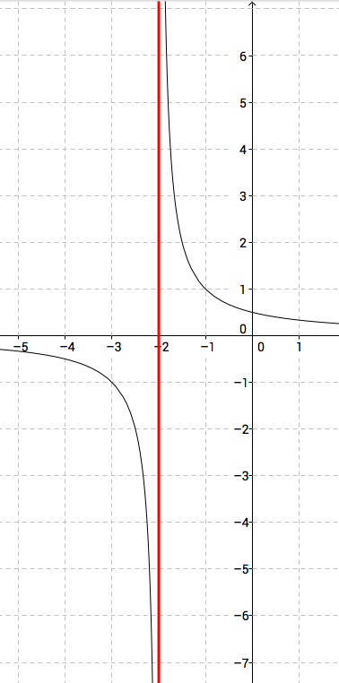
We can see that: $\lim_{x→-2^{+}}{f\left(x\right)=+∞}$ and that $\lim_{x→-2^{-}}{f\left(x\right)=-∞}$
Note: The graph will never cross the vertical asymptote (because it is a non
permissible value)
- horizontal or oblique asymptotes: model the behaviour of the graph when x
approaches infinity (when x is very large or very small)
ex: with $f\left(x\right)= \frac{x^{2}+3}{x^{2}+1}$
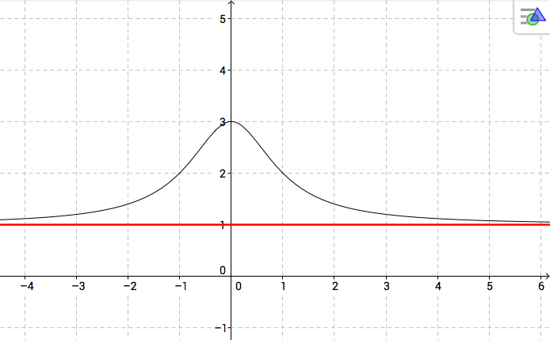

We can see that: $\lim_{x→∞}{f\left(x\right)=1}$ and that $\lim_{x→-∞}{f\left(x\right)=1}$

ex: with $f\left(x\right)= \frac{3x^{2}-5}{x+3}$
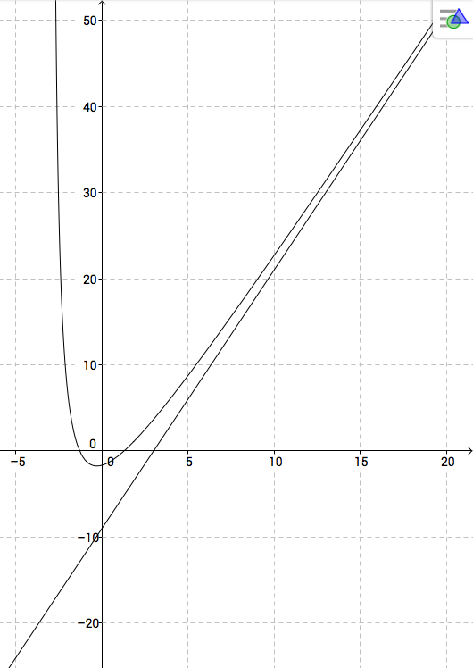
We can see that: $\lim_{x→∞}{f\left(x\right)=+∞}$, but also that $\lim_{x→∞}\left[f\left(x\right)-asymptote\right]=0$
Note: The graph can cross a horizontal or oblique asymptote, but towards infinity, the graph will look like that line…
II – How to determine the characteristics of a rational function?

In order to be able to graph a rational function, you need to collect as much information about it as possible: domain, x-intercepts, y-intercept, asymptotes, holes, and some extra values for a more precise graph…

- Domain: (vertical asymptotes and holes)
Determining the domain means finding the non-permissible values or restrictions. For rational expressions, you just need to find the zeros of the denominator.
Example: $f\left(x\right)= \frac{x^{2}+x-6}{x^{2}+4x+3}$
$x^{2}+4x+3=\left(x+3\right)\left(x+1\right)$, therefore D = $IR ∖\{-3,-1\}$
At a non-permissible value, you can have either a point of discontinuity or a vertical asymptote. To determine which one, you need to factor both the numerator and denominator and see if the factor responsible for the value can be simplified or not:
$f\left(x\right)= \frac{(x+3)(x-2)}{(x+3)(x+1)}$
At x = -3, there will be a hole because the factor can be canceled
At x = -1, there will be a vertical asymptote.
Note: Sometimes, you will be asked to give both coordinates of the hole.
To determine the y – coordinate, just replace the non-permissible value in the
simplified expression:
$f\left(x\right)= \frac{x^{2}+x-6}{x^{2}+4x+3}= \frac{(x+3)(x-2)}{(x+3)(x+1)}=\frac{x-2}{x+1}$
There is a hole when x = -3, so y = $\frac{-3-2}{-3+1}=\frac{5}{2}$
Point of discontinuity: $\left(-3,\frac{5}{2}\right)$
Your turn: Determine the domain, the vertical asymptotes and holes of $g\left(x\right)= \frac{2x^{2}+5x-12}{2x^{2}-13x+15}$

Once you have determined the domain, you only need to study the simplified version of your expression!!
- x- intercepts:
In order to find the x-intercepts, you need to solve $f\left(x\right)=0$
But for a fraction, a zero is a zero of the numerator, so x-intercepts are the zeros of the numerator that aren’t holes.
In the previous example: x = 2
- y- intercept:
Replace x by 0 to determine the y- intercept.
The easiest way to do it is to use the expanded form of your rational function.
In the previous example, $y=\frac{-6}{3}=-2$
- Horizontal and oblique asymptotes:
The equation of the horizontal or oblique asymptotes are the quotient of the long division…
Examples: (look at the graphs on your calculator)
* $f\left(x\right)=\frac{4x^{2}+x-4}{x^{2}-1}=\frac{x}{x^{2}-1}+4$ y = 4 is a horizontal asymptote
* $g\left(x\right)=\frac{2x^{2}-7x+4}{x-3}=\frac{1}{x-3}+2x-1$ y = 2x – 1 is an oblique asymptote.

Note: The difference between the function and the line is the fractional part with the remainder. When x gets very large, this fractional part becomes closer and closer to 0…

Method: There is a faster way to determine the nature of the asymptote: Just look at the leading terms on the numerator and denominator and divide them.
- If the degree of the numerator is less than the degree of the denominator, it will be a horizontal asymptote equation y = 0.
- If the degree of the numerator and denominator are the same, it will be a horizontal asymptote and the number k that you get when you simplify the quotient of the leading coefficients gives you the equation of the line y = k.
- If the degree of the numerator is 1 higher than the degree of the denominator, it will be an oblique asymptote and you will need to compute the long division to get the equation of the line.

Examples:
for $f(x)$: $\frac{4x^{2}}{x^{2}}=4$ (same degree - horizontal asymptote y = 4)
for $g(x)$: $\frac{2x^{2}}{x}$ (degree num is 1 higher than denom - oblique asymptote… need to do long division to get the full equation of the symptote)
If you get something like: $\frac{3x}{x^{2}}=\frac{3}{x}$ (denom higher degree - horizontal asymptote: y = 0)

Graphing: To graph a rational function, you need to determine the characteristics first.
Then you simplify your expression (cancel the factors responsible for holes).
Then graph the simplified expression (and add the hole).
If you’re unsure, use a table of values to plot more points!

Example: Graph $f\left(x\right)= \frac{x^{2}+x-6}{x^{2}+4x+3}$
(position the asymptote(s), the hole(s), the intercepts, and graph the simplified expression $y=\frac{x-2}{x+1}$)
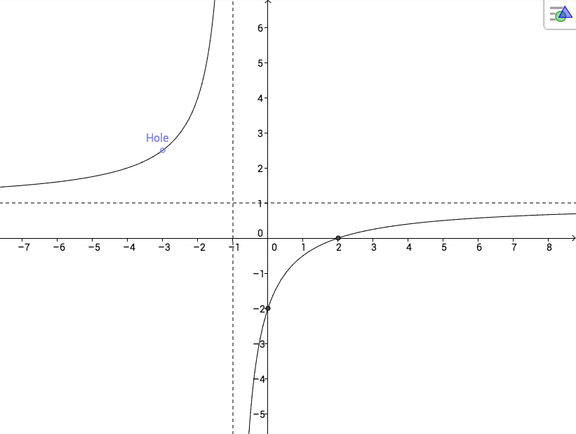

Note: If the simplified expression is a linear function, your graph will just be a line (with holes), and the line will be the oblique asymptote…
Example: $f\left(x\right)= \frac{(x+3)(x-5)}{x+3}$ (see page 1)

Applications: Determine the equation of a rational function from its graph (or characteristics):

Examples: Determine the equations of the following functions
- x-int: 5
vertical asympt: x = 1
horizontal asympt: y = 3
hole: @ 2
- x-int: 5
vertical asympt: x = 1 and x = 3
horizontal sympt: y = 4
hole: @ 6
- x-int: 5 and -4
vertical asympt: x = 2
horizontal sympt: y = 1
hole: @ -3

Hwk: p 451 # 1 – 5, 7, 8, 10, 11, 19, 20.

