Chapter 9 – Rational Equations

Example 1: $\frac{16}{x+6}=4-x$ Example 2: $\frac{x}{2x+5}+2x=\frac{8x+15}{4x+10}$

You can solve rational equations algebraically or graphically.

I – Algebraically (reminder from Precalc 11)
General method:
- Determine the non-permissible values.
- Write all the terms of the equation on the same denominator.
- Multiply both sides of the equation by the common denominator… (Denominators disappear)
- Solve
- Make your solutions are not non-permissible values…

Example 1:
- Non permissible values: $x≠-6$
- $\frac{16}{x+6}=\frac{(4-x)(x+6)}{x+6}$
- $16=(4-x)(x+6)$
- $x^{2}+2x-8=0$
$$∆=4-4×1×\left(-8\right)=36 \\ x=\frac{-2±6}{2}$$x = - 4 or x = 2
- solutions: $\left\{-4,\left.2\right\}\right.$ (I’ve checked the restrictions)
Example 2:
- Non-permissible values: $x≠-\frac{5}{2}$
- $\frac{2x}{2(2x+5)}+\frac{2×2x(2x+5)}{2(2x+5)}=\frac{8x+15}{2(2x+5)}$
- $2x+4x\left(2x+5\right)=8x+15$
- $2x+8x^{2}+20x=8x+15$
$$8x^{2}+14x-15=0$$$\left(2x+5\right)\left(4x-3\right)=0$ (alternative to the quadratic formula)
$x=-\frac{5}{2}$ or $x=\frac{3}{4}$
- Solution: $\left\{\frac{3}{4}\right\}$

II – Graphically:

General method:
- Graph both sides of the equation separately and look for the x-intercepts of the points of intersection.
OR
- Put all the terms on the same side, graph the expression and look for the zeros.

Example 1:
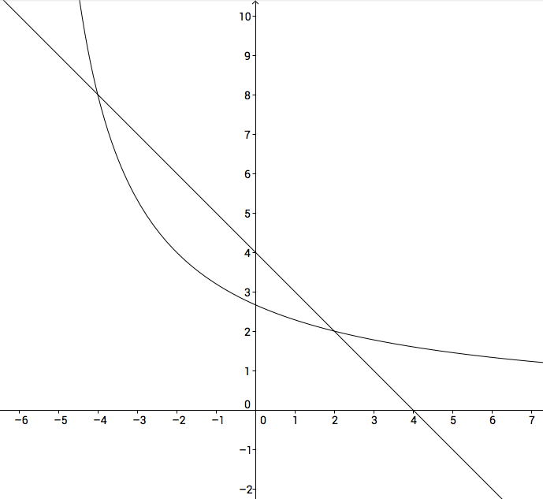or 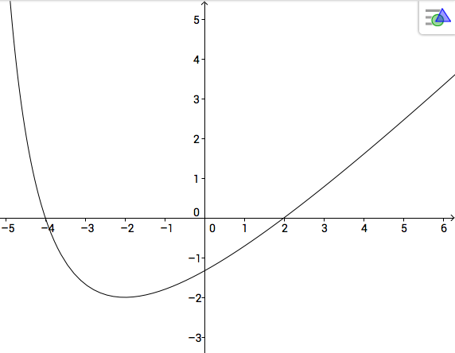
Both ways, you can read that the solutions are -4 and 2.

Hwk: p 465 # 2 - 5

