1.1 – HORIZONTAL AND VERTICAL TRANSLATIONS

Translating a graph means moving it along a straight line. The shape of the graph won’t change (no distortion), but it will be positioned somewhere else in the plane.

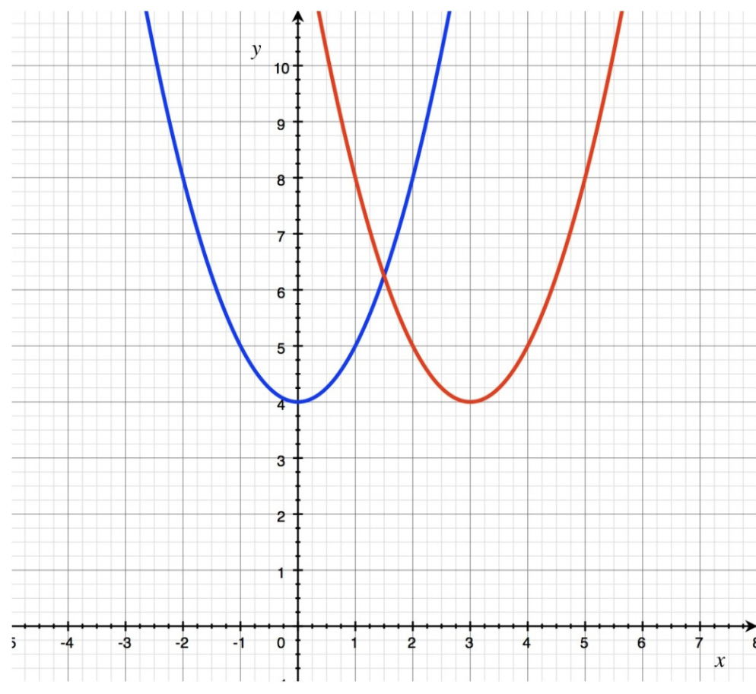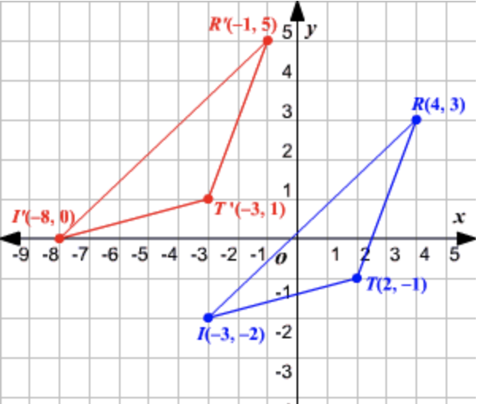

If you want to translate a graph vertically k units (up or down depending on the sign of k), you need to replace your « y » variable in the equation by « $y-k$ ».

Example 1: To translate the graph of $y=x^{2}$ 4 units up, you will graph $y-4=x^{2}$,
which is the same as graphing $y=x^{2}+4$
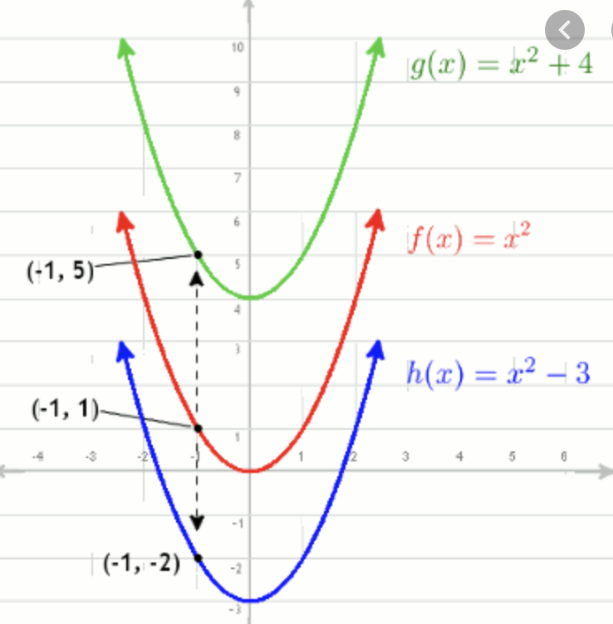

$$y=f\left(x\right)\underset{→}{ vertical translation k units } y=f\left(x\right)+k \\ Mapping: \left(x,y\right)\underset{→}{ vertical translation k units } (x, y+k)$$

Example 2: If $(3, -8)$ is on the graph of $y=f(x)$, what are the coordinates of the corresponding
point when the graph of f is translated 5 units down?
Example 3: What transformation has been applied to $y=2{\left(x-1\right)}^{2}-1$ when graphing the
function $y=2{\left(x-1\right)}^{2}+4$?

If you want to translate a graph horizontally h units (left or right depending on the sign of h), you need to replace your « x » variable in the equation by « $x-h$ ».

Example 4: To translate the graph of $y=x^{2}$ to the right 3 units, you will graph $y={(x-3)}^{2}$,
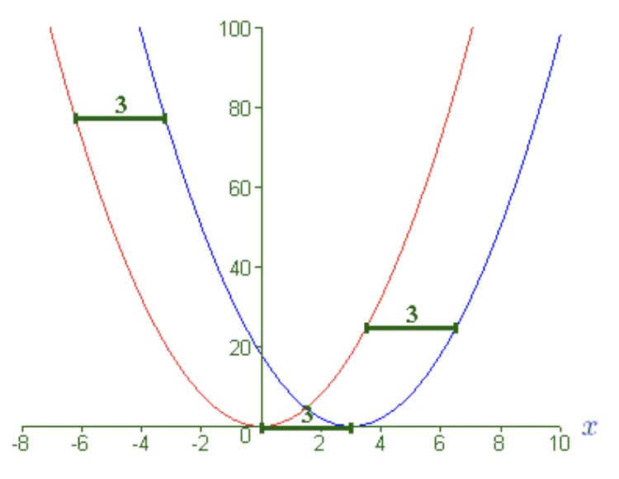

$$y=f\left(x\right)\underset{→}{ horizontal translation h units } y=f\left(x-h\right)$$

Mapping: $\left(x,y\right)\underset{→}{ horizontal translation h units } (x+h, y)$

Example 5: What function is a horizontal translation of $y=2x-5$ by 3 units to the right?
Example 6: If $(1,3)$ is on the graph of $y=f(x)$, what are the coordinates of the corresponding
point if the graph of f is translated 5 units to the left?
Example 7: What transformations have been applied to $y=x^{2}$ when graphing $y={\left(x-1\right)}^{2}+3$?
Example 8: Describe the transformation applied to f. Give the new equation.
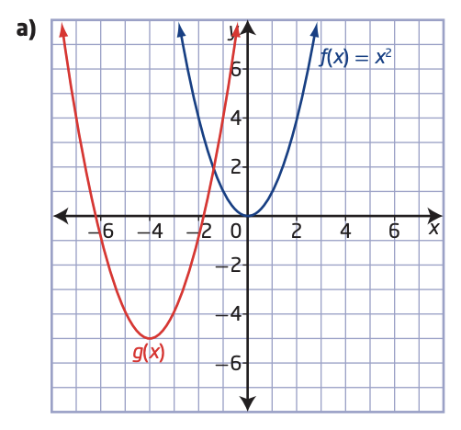 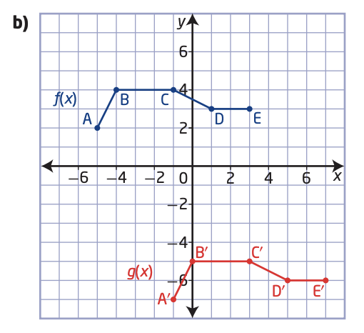

Hwk: p12 # 3 – 10, 11, 17, 18.
1.2 – REFLECTIONS AND STRETCHES

In this section, we want to stretch a graph on both sides of an axis.
Here is an example of a vertical stretch with factor 3.
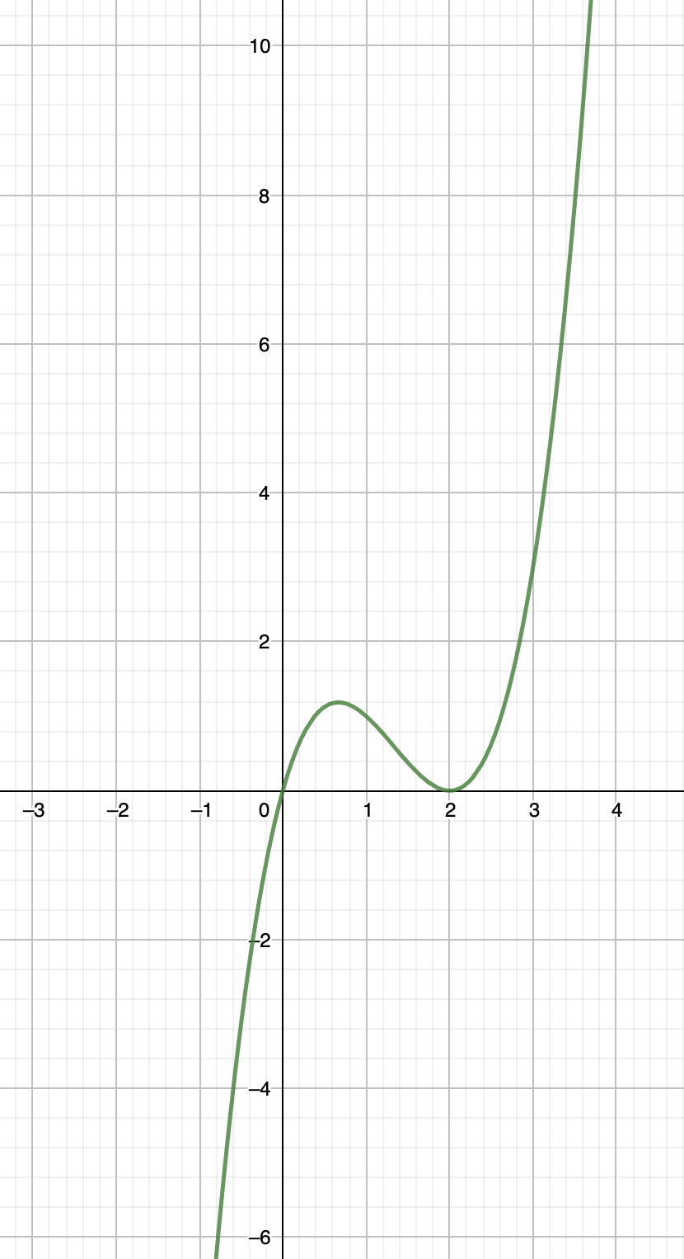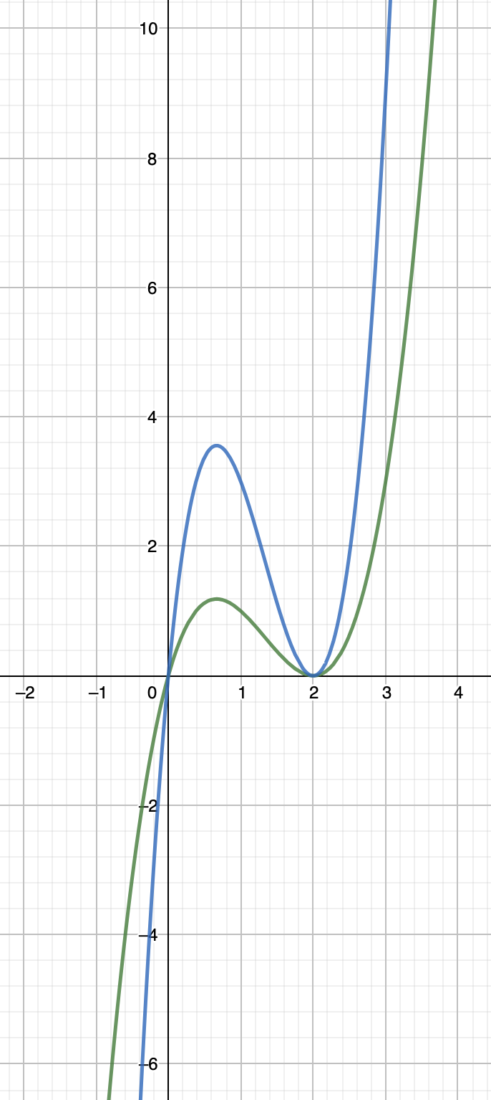
Here is an example of a horizontal stretch with factor 2.

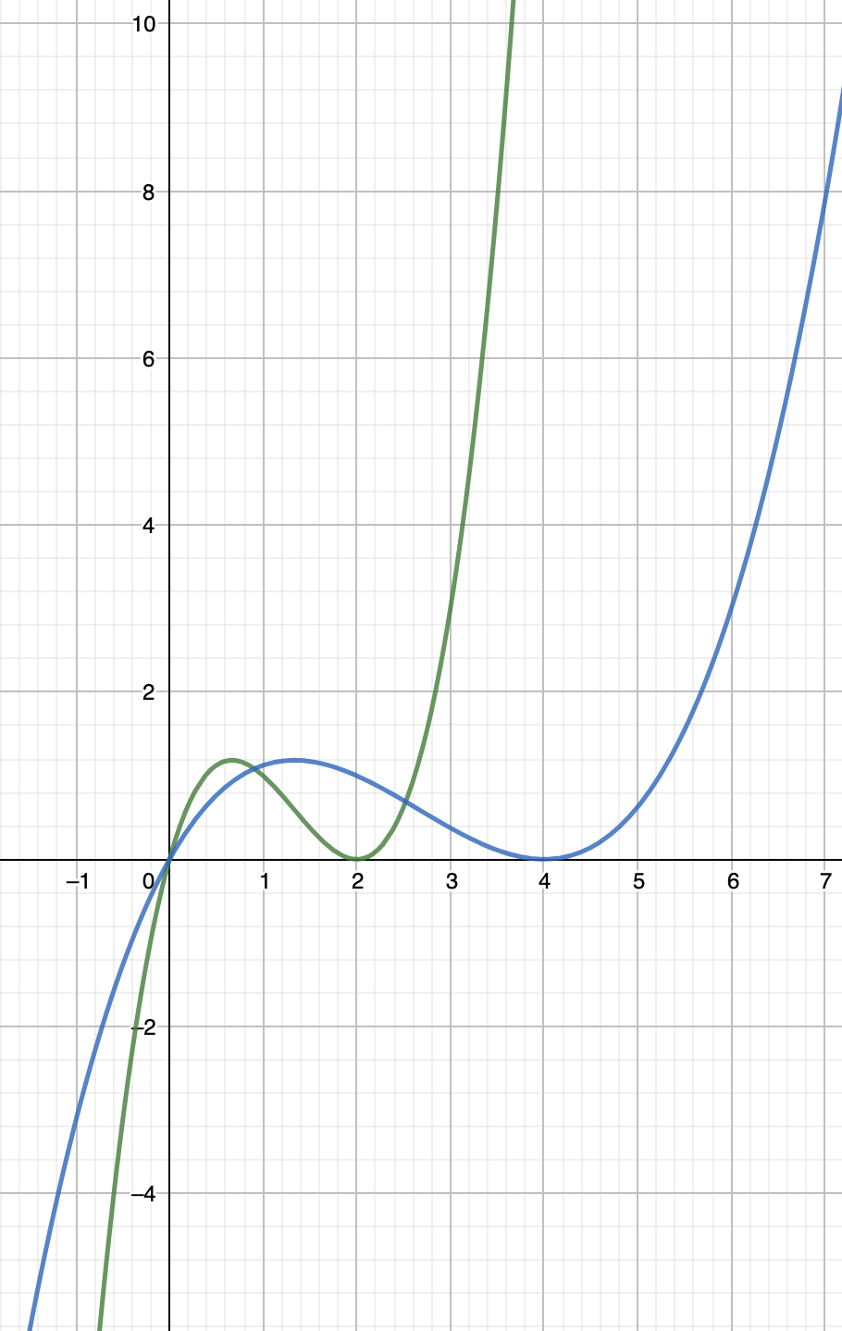

If you want to stretch a graph vertically with a factor a (remember that a factor is always a positive number) you need to replace your « y » variable in the equation by « $\frac{1}{a}y$ ».

Example 1: Apply a vertical stretch with factor 4 to the function $y={\left(x+2\right)}^{2}$

$$y=f\left(x\right)\underset{→}{ vertical stretch factor a } y=af\left(x\right)$$

Mapping: $\left(x,y\right)\underset{→}{ vertical stretch factor a } (x,a y)$

Example 2: Apply a vertical stretch with factor 3 to the function $y=2x^{2}-x+1$
Example 3: If $(3,-8)$ is on the graph of $y=f(x)$, what is the corresponding point if you stretch
the graph vertically with a factor 3?

If you want to stretch a graph horizontally with a factor b (remember that a factor is always a positive number) you need to replace your « x » variable in the equation by « $\frac{1}{b}x$ ».

Example 4: Apply a horizontal stretch with factor 2 to $y=8x-3$

$$y=f\left(x\right)\underset{→}{ horizontal stretch factor b } y=f\left(\frac{1}{b}x\right)$$

Mapping: $\left(x,y\right)\underset{→}{ horizontal stretch factor b } (bx,y)$

You can also see it as: $y=f\left(x\right)\underset{→}{ horizontal stretch factor \frac{1}{b} } y=f\left(bx\right)$

Example 5: Apply a horizontal stretch with factor $\frac{1}{3}$ to the graph of $f\left(x\right)=5x^{2}+2x-1$.

Example 6: If $\left(10,15\right)$ is on the graph of $y=f(x)$, what is the corresponding point on the graph
of $y=f(5x)$?

Note that if the factor of a horizontal stretch is greater than 1, then the graph will look wider, but if the factor is between 0 and 1, the graph will look thinner…

If you want to reflect a graph vertically (about or around the x-axis) you need to replace your « y » variable in the equation by « $-y$ ».

Example 7: Apply a vertical reflection to the graph of $f\left(x\right)=5x^{2}-5x+3$

$$y=f\left(x\right)\underset{→}{ vertical reflection } y=-f\left(x\right)$$

Mapping: $\left(x,y\right)\underset{→}{ vertical reflection } (x,-y)$

Example 8: Apply a reflection about the x-axis to the graph of $f\left(x\right)=2\sqrt{x-3}+1$

If you want to reflect a graph horizontally (about or around the y-axis) you need to replace your « x » variable in the equation by « $-x$ ».

Example 9: Apply a horizontal reflection to the graph of $f\left(x\right)=5x^{2}-5x+3$

$$y=f\left(x\right)\underset{→}{ horizontal reflection } y=f\left(-x\right)$$

Mapping: $\left(x,y\right)\underset{→}{ horizontal reflection } (-x,y)$

Example 10: Apply a reflection about the y-axis to the graph of $f\left(x\right)=2\sqrt{x-3}+1$

Example 11: If the point $(2,-3)$ is on the graph of $y=f(x)$, what is the corresponding point on
the graph of $y=f(-x)$?

Example 12: Write the equation of each transformed graph:

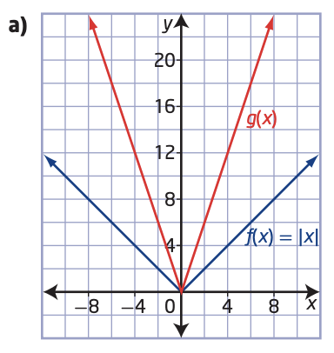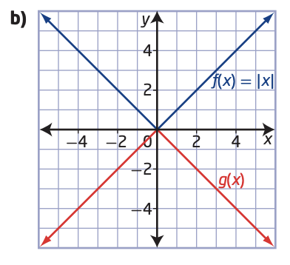

Hwk: p 28 # 3, 5 – 7, 14, 15
1.3 – COMBINING TRANSFORMATIONS

If we apply the 6 types of transformations from the previous lessons, we get:

$$y=af\left(b\left(x-h\right)\right)+k$$

If the equation is matching this format, then the transformations are applied from left to right in the order you see them.

In other words, in this format, the stretches and reflections are performed (in any order) BEFORE the translations.

If the format doesn’t match, then you will have the wrong horizontal translation.

Example 1: What transformations do you apply to $y=f(x)$ to graph $y=-2f\left(\frac{1}{2}x+4\right)-3$?

Example 2: Which transformations have been applied to the graph of f to get the graph of g?
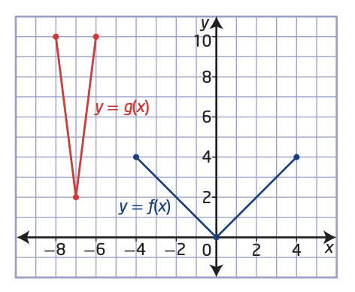
Example 3: What transformations have been applied to $y=x^{2}$ to graph $y=3{\left(10-5x\right)}^{2}+1$?

Example 4: If $(-2, 5)$ is on the graph of $y=f(x)$ what is the corresponding point on the graph
of $y=-5f\left(\frac{1}{2}x+1\right)-7$?

Note: - Vertical transformations (“outside” the function) affect the y coordinates.
- Horizontal transformations (“inside” the function) affect the x coordinates.

Hwk: p 38 # 1, 3, 4, 6 – 8, 9cdf, 10, 11, 15 – 17.
p 72 # 1ac, 2 – 4, 5ab, 6, 10, 11.
1.4 – INVERSE OF A RELATION

The inverse of a relation is a relation that has the reverse action on the variable.

For example, if $f\left(x\right)=2x$ (the action of f is to double the variable), then $g\left(x\right)=\frac{1}{2}x$ is its inverse.
We can see on a table of values:
$$x$$ | $$f(x)$$
-1 | -2
0 | 0
1 | 2
2 | 4

$$x$$ | $$g(x)$$
-2 | -1
0 | 0
2 | 1
4 | 2

We can see that the x- values of the function f correspond to the y values of g and vice versa.
Example 1: What is the inverse function of $y=\sqrt{x}$ ? Show how it works on the table of values…

I – Determining equations of inverses:
- Exchange the x and the y variables.
2- Solve for the new y variable.
Remember: The domain of the original function is the Range of the inverse, and vice versa.
Example 2: Determine the inverse of $f\left(x\right)=3x+6$. Determine the domain and Range of the inverse.

Example 3: Determine the inverse of $f\left(x\right)=x^{2}-4$. Determine the domain and Range of the inverse.

Example 4: Determine the inverse of $f\left(x\right)=x^{2}+6x+8$. Determine its domain and Range.

Notes: - Be careful, the inverse of a function is not necessarily one function.
- When the inverse of f is one function, we can name it $f^{-1}$. If it is several functions, you can’t.
- If you have a quadratic function, the vertex form is the way to go…
- If the variables have been chosen because of what they mean, then you don’t exchange them to
start with, but you solve the equation for the other one to get the inverse.
Example:
Here is the equation that relates the temperature in degrees Celsius to the temperature in degrees
Fahrenheit: $F=\frac{9}{5}C+32$
Written that way, it is used to convert degrees Celsius to degrees Fahrenheit.
If we solve it for C (instead of F), we will get the inverse function, which would be used to con
vert degrees Fahrenheit to degrees Celsius.

II – Graph of an inverse
To graph an inverse, you can just use a table of values of the original function and exchange the coordinates.
Example 1: Graph the inverse of $y=\sqrt{x+3}$
Notice that there is a symmetry between the 2 curves about the line $y=x$.
This is always true between to inverse graphs.
II – Restricting the domain of a function
Sometimes, in the future, we will need an inverse function.
When the inverse is not one function, we will need to restrict the domain of the original function (keep only the part that we need) in order to get a single function.
Example 2: Let’s consider the function $y=2{\left(x+3\right)}^{2}-2$
Let’s graph it as well as its inverse.
We can see that the inverse is not a function (if we check with the vertical line test). We could have looked at the original function and use the corresponding “horizontal line test” to predict it.
The vertical line test tells us if what we are looking at is “y as a function of x”.
The horizontal line test tells us if the inverse of what we are looking at will be a function. It also tells us how many functions we will need to express the inverse…
In the previous example, if we only keep half of the parabola, then the corresponding inverse will be a function.
So if we need to inverse to be a function, we need to restrict the domain to either $[-3, ∞)$ or to $(-∞,-3]$.
Example 3: Consider $y=2x^{2}-4x-3$
a) Graph it.
b) Is the inverse going to be a function? Justify
c) Determine the inverse algebraically
d) Restrict the domain of the function so that the inverse is a function.
e) Graph the inverse of the restricted function on the same plane.

Hwk: p 51 # 2 – 5, 8 – 10, 12acf, 13zb, 15, 16, 21.
Review: chapter 1 p 56 – 59 and 2.1 p 99 # 1 – 7

