Chapter 11 TEST

Calculator allowed

Multiple Choice
Identify the choice that best completes the statement or answers the question.

____ 1. The number of different ways that 9 bikes can be locked in a bike rack is
A. | 3 628 800 | C. | 40 320
B. | 20 160 | D. | 362 880

____ 2. Evaluate .
A. | 32 432 400 | C. | 6435
B. | 163 459 296 000 | D. | 259 459 200

____ 3. After the tryouts for the volleyball team, the coach selects 14 people to join the team. Due to a problem with transportation, only 9 people can travel. In how many ways can the coach pick the people to go?
A. | 726 485 760 | C. | 630
B. | 2002 | D. | 126

____ 4. For a mock United Nations, 6 boys and 7 girls are to be chosen. If there are 12 boys and 9 girls to choose from, how many groups are possible?
A. | 846 720 | C. | 960
B. | 33 264 | D. | 120 708 403 200

____ 5. Determine the coefficient, a, for the term of the binomial expansion of .
A. | 35 | C. | 792
B. | 60 | D. | 3 991 680

Short Answer
6. Determine ${}_{6}^{}{C_{2}}$ in two different ways.

8. Josie goes to the local submarine sandwich shop. She can choose from 4 types of breads. There are 3 types of cheese, 8 types of vegetables, and 7 types of sauce. Assuming that Josie only chooses one type of bread, one cheese, one vegetable, and one sauce for her sandwich, how many choices does she have?

9. Joe wants to travel from his home to school. How many routes can Joe take from his house to school if he only moves east and south.
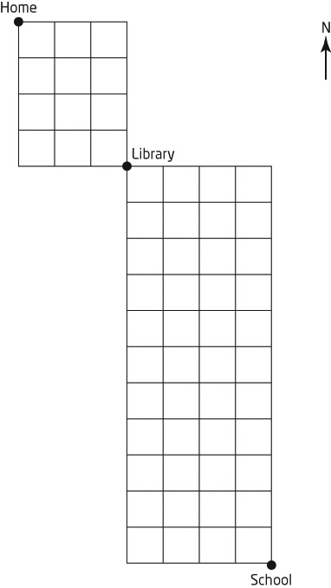

10. Sun Eui and Pattie are arguing about the number of ways the letters in PERMUTATION and COMBINATION can be rearranged. Sun Eui believes that there are more ways to rearrange PERMUTATION, while Pattie thinks that COMBINATION has more unique arrangements. Which person is correct? How many ways are there to arrange each of them?

11. Show that .

12. A math teacher is preparing a quiz for all of the students in grade 12. She wants to give each student the same questions, but have each student’s questions appear in a different order. If there are 128 students in the grade 12 class, what is the least number of questions the quiz must contain so everyone gets a test with the questions in a different order.

13. a) Solve for n: $2\left({{}_{n}^{}C}_{2}\right)={{}_{n+1}^{}C}_{3}$ b) Solve for n: ${nP}_{2}=30$

14. Simplify the expression $\frac{{{}_{n}^{}C}_{5}}{{{}_{n-1}^{}C}_{3}}$.

15. Isak, Aimee, Max, Myriane and Derek are going to the movie theatre. In how many ways can they sit in a row if:
a) Myriane and Derek want to sit next to each other?

b) Myriane and Derek want to be next to each other and Aimee and Isak want to sit next to each other.

c) Aimee and Max don’t want to sit next to each other.

16. Expand using the binomial theorem: 

