**Chapter 1 TEST**

**Multiple Choice**  **[7]**

**____ 1.** What is the equation of the transformed function, *g*(*x*), after the transformations are applied to the graph of the base function **, to obtain the graph of *g*(*x*)?



|  |  |  |  |
| --- | --- | --- | --- |
| **A** | $$g\left(x\right)={\left(x-5\right)}^{2}-3$$ | **C** | $$g\left(x\right)={\left(x+3\right)}^{2}+5$$ |
| **B** | $$g\left(x\right)={\left(x+3\right)}^{2}-5$$ | **D** | $$g\left(x\right)={\left(x-5\right)}^{2}+3$$ |

**____ 2.** Given the function with a domain of  and a range of , What are the values of *h* and *k* ?

|  |  |  |  |
| --- | --- | --- | --- |
| **A** | $h=8$ and $k=-5$ | **C** | $h=-5$ and $k=8$ |
| **B** | $h=-8$ and $k=5$ | **D** | $h=5$ and $k=-8$ |

**____ 3.** When a function is reflected in the *x*-axis, the coordinates of point (*x*, *y*) become

|  |  |  |  |
| --- | --- | --- | --- |
| **A** | (*x, –y*) | **C** | (*–x, –y*) |
| **B** | (*–x, y*) | **D** | (*x, y*) |

**____ 4.** When $b<0$, the function $g\left(x\right)=\frac{b}{x}$ is obtained from $f\left(x\right)=\frac{1}{x}$ by applying:

|  |  |
| --- | --- |
| **A** | A vertical stretch factor and a horizontal reflection |
| **B** | A vertical stretch factor *b*. |
| **C** | A horizontal stretch factor *b*. |
| **D** | A horizontal stretch factorand a vertical reflection |

**____ 5.** What are the coordinates of the invariant point(s) when the function  is reflected in the *y*-axis?

|  |  |  |  |
| --- | --- | --- | --- |
| **A** | (2, –2) | **C** | (0, –2) |
| **B** | (–2, 0) and (2, 0) | **D** | (0, 2) |
|  |  |  |  |

**____ 6.** When the value of *a* is less than –1, the function ** has what relationship to the base function ?

|  |  |
| --- | --- |
| **A** | *f*(*x*) is compressed vertically |
| **B** | *f*(*x*) is reflected and compressed vertically |
| **C** | *f*(*x*) is stretched vertically |
| **D** | *f*(*x*) is reflected and stretched vertically |

**____ 7.** Which choice best describes the combination of transformations that must be applied to the graph of  to obtain the graph of ?

|  |  |
| --- | --- |
| **A** | a horizontal stretch by a factor of 2 and a horizontal translation of 2 units to the left |
| **B** | a horizontal stretch by a factor of  and a horizontal translation of 4 units to the right |
| **C** | a horizontal stretch by a factor of  and a horizontal translation of 2 units to the right |
| **D** | a horizontal stretch by a factor of –2 and a horizontal translation of 2 units to the right |

**Short Answer**

**8.** Determine the equation, in standard form, of the parabola after being transformed from  by the given translations: 2 units to the left and 1 unit up **[2]**

**9.** If (2,-7) is on the graph of $y=f(x)$, what is its corresponding point for the transformed function $y=-5f\left(2(x+3)\right)-6$  
? Use the table below to list the transformations and see the effect on the coordinates. **[5]**

|  |  |
| --- | --- |
| Transformation | Start point: (2,-7) |
|  |  |
|  |  |
|  |  |
|  |  |
|  | End point: |

**10.** Determine the inverse of the following functions. **[6]**

**a)** 

**b)** 

**c)** 

**11.** a)Given the relation $y=g(x)$**,** write the equation that will reflect its graph over the y axis and stretch it vertically by a factor 3. **[1]**

b) Same question if $g(x)=2\sqrt{x-3}-4$**[2]**

**Problem**

**12.** Consider the function $f\left(x\right)= {\left(x-3\right)}^{2}-5$.

**a)** State the domain and range of the function. **[1]**

**b)** Is its inverse a function or not? (circle the answer below)  
 If yes, determine the domain and the range of the inverse.   
 If not, then restrict the domain of the original function so that its inverse is a function, and state the   
 domain and the range of the inverse function. **[2]**  
  
yes / no Restricted domain if needed:

Domain of the inverse function:

Range of the inverse function:

**c)** Graph the restricted function and its inverse on the same set of axes (include the line *y = x*). **[2]**

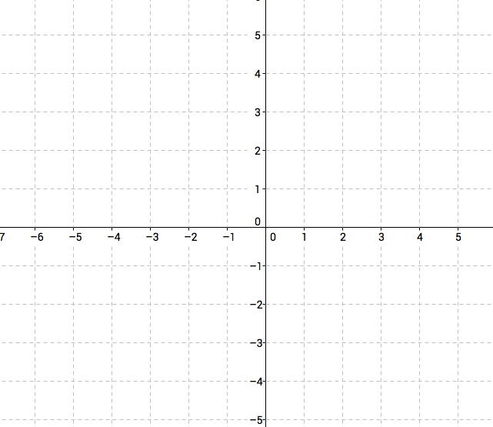

**13.** The cost of renting a car for a day is a flat fee of $50 plus $0.12 for each kilometre driven. Let *C* represent the total cost of renting a car for a day if it is driven a distance, *x*, in kilometres. **[2]**

**a)** Write the total cost C for the car rental as a function of the number of kilometres *x*.

**b)** What would the inverse of this function represent?

**c)** Determine the inverse function.