Chapter 6 TEST
Graphing Calculator allowed (but mostly useless)

Multiple Choice
Identify the choice that best completes the statement or answers the question.

____ 1. What does the expression simplify to?
A. |  | C.
B. |  | D.

____ 2. Which expression is equivalent to 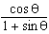?
A. | 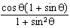 | C. | 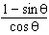
B. | 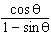 | D. | 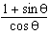

Short Answer

3. Prove that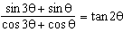 for $θ=\frac{π}{6}$

4. Solve $sin2x+2cosx=0$, for $-π≤x≤3π$.

5. What is the general solution, in radians, to the equation 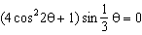?

6. Solve $2\cos^{2}x+3sinx-3=0$ over $0≤x<2π$

7. Consider: $cscx+cotx=\frac{sinx}{1-cosx}$ .
a) Determine the restrictions.
b) Prove that it’s an identity.

8. Determine the exact value of without a calculator (show your work)
9. Consider 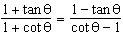.
a) Determine the restrictions.
b) Prove that it’s an identity.

