USUAL FUNCTIONS REVIEW

I – Reminders on Functions:

A function is an action applied to a variable.
Example: The function f that “doubles” could be written: $f\left(x\right)=2x$
x is the independent variable. It can be replaced by a number or stay random.
y is the result: It’s f(x).

The domain of a function is the set of all the possible values that the independent variable (x) can take. We can determine the domain by looking at the expression or at the graph.
For now, we have only had restrictions on the domain when there is a denominator (it can’t be 0), when there is a square root (the radicand can’t be negative) or when it’s a “real-life” situation (sometimes a variable has to be a whole number for example) …

The range of a function is the set of all the possible values that the dependent variable (y) can take on the domain. We can usually determine the range when we look at the graph but not really by looking at the expression.

The x-intercepts are the values of x for which the graph crosses the x-axis. We can determine them by replacing y by 0 in the equation.

The y-intercepts are the values of y for which the graph crosses the y-axis. We can determine them by replacing x by 0 in the equation.

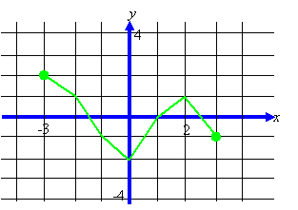

II – Usual Functions:

- Linear functions: The graphs will be straight lines
slope-intercept form general form slope-point form
$$m=\frac{vertical change}{horizontal change}=\frac{y_{2}-y_{1}}{x_{2}-x_{1}}$$
You add to your bank account the same amount each week.
On the 6th week, your balance is $350. On the 11th week, your balance is $450.
Examples:
i) Determine the equations for the following linear situations:
a) b) c)
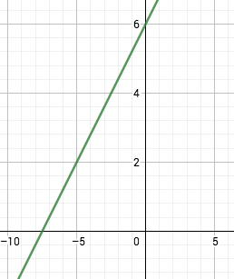 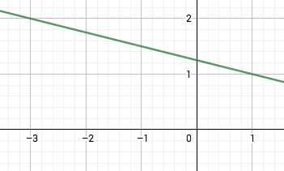
ii) Is the point (3;5) on the line: $y=\frac{2}{3}x+3$?
iii) Graph the following lines:
a) $y=-\frac{2}{3}x+5$ b) $y+2=\frac{2}{7}(x-1)$ c) $2x-3y=24$
Reminders: Parallel lines have the same slope
Perpendicular lines have slopes that are opposite and reciprocals.
- Quadratic functions: The graphs will be parabolas (opening up or down)
Factored form General Form Vertex Form
Great for the zeros Vertex: $\left(\frac{-b}{2a}; \right)$ Great for the vertex
Examples:
a) $y=x^{2}-2x-15$
b) $y=2{(x-1)}^{2}+5$
To determine the zeros, you can factor, or use the quadratic formula $\left(Δ=b^{2}-4ac and x=\frac{-b±\sqrt{Δ}}{2a}\right)$
To determine the equation of a parabola given its graph, use the vertex form and determine p, q, and then a (using the coordinates of a point on the graph).
Example:
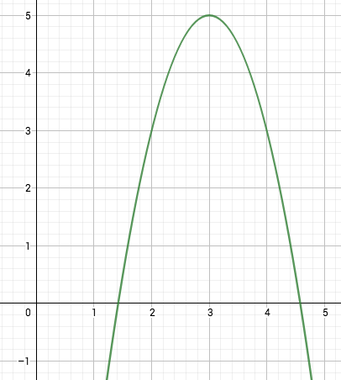

- Absolute Value functions: The absolute value transforms any number into a positive number…
Examples: $\left|-5\right|=5$ ; $\left|5\right|=5$
Examples: 1) $y=\left|x\right|$ 2) $y=\left|-2x+3\right|$ 3) $y=\left|x^{2}-2x-15\right|$
Piecewise definition:
$y=\left|x\right|$ $y=\left|-2x+3\right|$ $y=\left|x^{2}-2x-15\right|$
D = D = D =
R = R = R =
Your turn: Define the following absolute values piecewise:
a) $y=\left|x-7\right|$
b) $y=\left|x^{2}-x-20\right|$
- Square Root functions:
Examples: 1) $y=\sqrt{x}$ 2) $y=\sqrt{2x-8}$
D = D =
R = R =
Hwk: converting quadratics worksheet &. Usual functions worksheet

III – Solving Usual Equations: SEE ORGANIZER

- Algebraically:
This should be the default method.
Each type of equation will be solved differently, because there isn’t 1 method that works for them all.
- Graphically:
This method is only used when we don’t know how to solve the equation algebraically (if it isn’t a usual type of equation) or if we don’t need to be precise. Graphing calculators (or technology in general) will help us do it fast and with great approximations.
The idea is to graph each side of the equation separately and look for the points of intersection…
(x values only)

Hwk: Usual equations worksheet & p 96 # 2 – 4, 6, 7, 11, 13, 14
Review 2.3 p 100 – 101 & p 102 # 2, 7, 12

