USUAL FUNCTIONS - worksheet

- Rewrite in slope-intercept form:
a) $3x-5y+12=0$ b) $y-4=\frac{2}{3}(x+4)$
- Determine the equations of the following linear situations:
a) b)
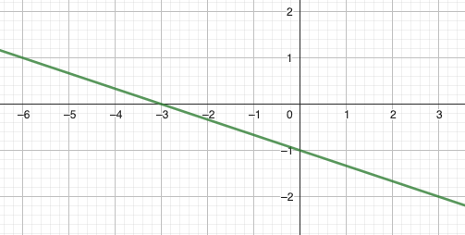 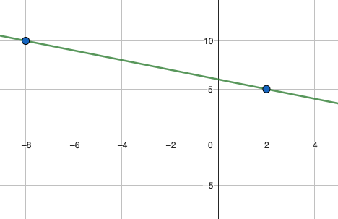
c) Your phone bill is made of a flat fee and some extra charges for each GB that you have downloaded. If you downloaded 100GB, your bill is $70. If you downloaded 40GB, your bill is $61.
- Graph the following functions with precision:
a) $y=-\frac{1}{7}x+2$ b) $y-3=\frac{4}{9}(x-2)$ c) $5x-7y=35$
- Is the point (-300 ; 100) on the line: $y=\frac{2}{3}x+102$?
- Let’s consider A(0 ; 4), B(5 ; -3), C(2 ; -5) et D(-3 ; 2).
a) prove that lines (AB) and (CD) are parallels.
b) Is ABCD a rectangle ?
- Graph the following functions. Determine their exact characteristics. Make a table of values. Détermine their domain and range.
a) $y=-2x^{2}+20x-42$
b) $y=(x-5)(x+8)$
c) $y=\left(x+3\right)\left(5-3x\right)$
d) $y={(x+5)}^{2}-3$
- Determine the equations of the following parabolas:
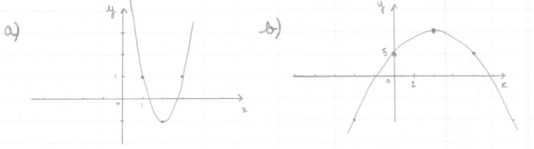
- Graph the following functions and write them piecewise:
a) $y=\left|3x-10\right|$ b) $y=\left|x^{2}-4x-12\right|$
- What are the characteristics of a reciprocal function?
- Graph the following functions:
a) $y=\frac{1}{x-1}$ b) $y=\frac{1}{x+2}$
- Graph: a) $y=\sqrt{x-5}$ b) $y=\sqrt{3x+9}$

