QUIZ 1.1 – 1.2

- Identify the values of the parameters a, b, h and k for each of the following functions. Explain what transformation they represent :
a) $y=f\left(x-2\right)+3$ a= b= h = k =
b) $y=5f(2x)$ a= b= h = k =
c) $y=3\left|x\right|-4$ a= b= h = k =
d) $y={\left(x+5\right)}^{2}+1$ a= b= h = k =
- Given the equation of f(x) in each case, determine the equation of the transformed function g(x) after a translation of 2 units to the right and 5 units down. Simplify.
a) $y=f(x)$
b) $f\left(x\right)= x^{2}$
c) $f\left(x\right)= \left|x\right|$
d) $f\left(x\right)=3x^{2}-5x+1$
- Determine, in each case, the equation of the function obtained after reflecting $y=f(x)$ around the x-axis and stretched it horizontally by a factor of 3. Simplify.
a) $y=f(x)$
b) $f\left(x\right)= x^{2}$
c) $f\left(x\right)= \left|x\right|$
d) $f\left(x\right)=3x^{2}-5x+1$
- Determine, in each case, the equation of the function obtained after reflcting $y=f(x)$ around the y-axis and stretched it vertically by a factor of 2. Simplify.
a) $y=f(x)$
b) $f\left(x\right)= x^{2}$
c) $f\left(x\right)= \left|x\right|$
d) $f\left(x\right)=3x^{2}-5x+1$
- Given the graph of f(x), graph the transformed function : $y=f\left(x+2\right)-7$ on the same set of axes and fill the table.
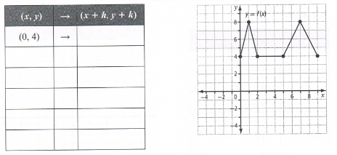
- The graph of the function $f\left(x\right)= \frac{1}{x}$ is translated 5 units to the left and 2 units up to form the transformed function $y = g(x)$. Determine the equation of $y = g(x)$:
- a) If $f\left(x\right)= \sqrt{x}$ and you want to stretch its graph vertically so it’s twice taller, what is the equation of the function you want to graph ?
b) If you compare the graphs of $f\left(x\right)= \sqrt{x}$ and $g\left(x\right)= \sqrt{3x}$, what can you say about the graph of $g$ compared to the graph of $f$?
c) If $f\left(x\right)= x^{2}+2x-3$, and you want $g\left(x\right)$ to have a graph similar but twice wider (horizontal), what equation would be appropriate for $g\left(x\right)$? What are the invariant points ?
- Graph the following transformation of $f(x)$ and write its equation (with respect to f): reflection in the x-axis and a vertical stretch by a factor of $\frac{1}{2}$.
