QUIZ 3.1 – 3.2

- Determine whether each function is a polynomial function. If it is, give its degree, constant term, leading coefficient and graph its general shape (without being precise at all). [6]
a) $y= 3x^{4}-5x+2$ b) $y= 2^{x}+4$
c) $y=5$ d) $y= x^{-2}+3x-1$
- Use synthetic division to divide $x^{3}+3x^{2}-2x+5$ by $x+1$. [2]
- For each graph of a polynomial function, determine the degree, the sign of the leading coefficient and the number of x-intercepts. [4.5]
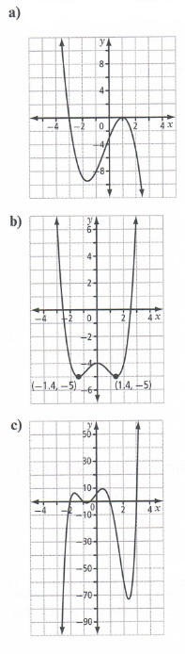
- a) List all the possible numbers of x-intercepts for a degree 3 polynomial ? [1]
b) List all the possible numbers of x-intercepts for a degree 4 polynomial ? [1]
- A skateboard manufacturer determines that its profit, P, in dollars, can be modelled by the function $P\left(x\right)= 1000x+1.25 x^{4}-3200$, where x represents the number, in hundreds, of skateboards sold. [6.5]
a) What are the restrictions on the domain of this function in this situation?
b) Which window should you use on your calculator to see the general shape of the graph considering the restrictions on the domain…
x-min= x-max=
y-min= y-max=
c) What is the y-intercept of the function ? How do you find it without graphing the function ? What does it represent in this context ?
d) What do the x-intercepts represent in this context ?
e) What is the profit from the sale of 1200 skateboards ?
f) Approximately, how many skateboards does the manufacturer need to sell in order to make a $ 8 000 profit ? Don’t show your work.
- Divide $2x^{2}-x+5$ by $x+3$ using long division. [2]
- Determine the remainder when $2x^{3}+3x^{2}-17x-30$ is divided by $x-2$. [1]
- Determine the value of k if the remainder is -2 for $\left(2x^{3}-5x^{2}-4x+k\right)÷\left(x+1\right)$ [1.5]
- For what value of m will the polynomial $P\left(x\right)= x^{3}+6x^{2}+mx-4$ have the same remainder when it is divided by $x-1$ and $x+2$? [1.5]
- Can the following polynomials be factored by $\left(x+2\right)$? If so, do it. [3]
a) $x^{3}-4x^{2}-7x+10$ b) $3x^{3}-5x+1$

