QUIZ 5.1 – 5.3

- Determine the amplitude and the period in degrees and in radians.
a) $y=2 cosθ$
b) $y=-3\cos\left(\frac{1}{2}θ\right)$
c) $y=0.25\sin\left(0.25θ\right)$
- Determine the amplitude and the period in radians :
a)
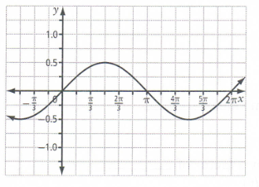
b)
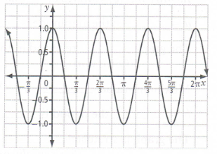
- Identify the characteristics (amplitude, max, min, period, intercepts) for both functions and graph $y= -2\sin\left(4θ\right)$ on at least 2 periods.
a)
 | $$y=\sin{θ}$$ | $y= -2\sin\left(4θ\right)$
Amplitude
max
min
period
y-intercept
$θ$ -intercepts
b) Same question with no graphing.
 | $$y=\cos{θ}$$ | $$y=2\cos\left(\frac{1}{2}θ\right)$$
Amplitude
max
min
period
y-intercept
$θ$ -intercepts

 | $$y= -5\sin\left(\frac{1}{2}\left(θ-90°\right)\right)+15$$ | $$y=\cos\left(\frac{1}{3}\left(θ-π\right)\right)+3$$
amplitude
period
Phase shift
Centre line
domain
Range
- Same question and graph $y=\cos\left(\frac{1}{3}\left(θ-π\right)\right)+3$ :

- Graph over 2 periods, give its domain, its period and the equations of its asymptotes, x is in radians.

- Determine the equation of the function represented below. Explain why you chose cos or sin.
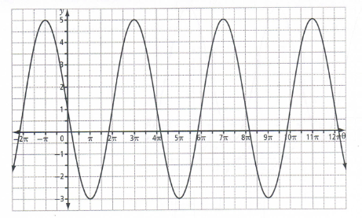
- Determine the equation of the function represented below. Explain why you chose cos or sin.
