QUIZ 7&8 – Part I

- Determine if the following functions are exponential functions or not.
$y=x^{5}$ | | $y={0.1}^{x}$ | | $y=\sqrt[3]{x}$ | | $y=x^{0.5}$ |

- Which function corresponds to which graph?
____ a) $y=5^{x}$ ____ b) $y=7^{x}$ ____ c) $y={\left(\frac{3}{4}\right)}^{x}$ ____ d) $y={0.2}^{x}$
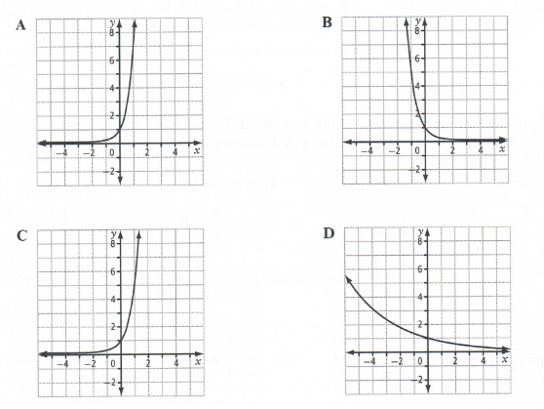
- Determine the list of transformations applied to basic exponential functions to get the following :
a) $y=4^{2\left(x-5\right)}-6$
b) $y=2^{-x+1}-5$
- The determine the equations of the following graphs :
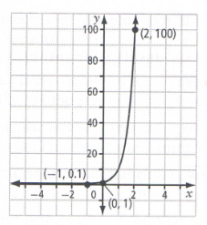 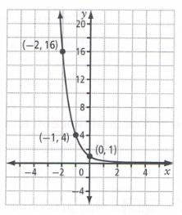
- Graph $f\left(x\right)=2^{x}$ and $g\left(x\right)=2^{-x}-5$.
Determine their Domain and Range, if they are increasing or decreasing, their y-intercept and the equation of their asymptote if any.
- Rewrite in logarithmic form:
a) $3^{5}=243$
b) ${16}^{\frac{1}{2}}=4$
c) $e^{2x-5}=y-1$
- Rewrite in Exponential form:
a) $\log_{2}32=5$
b) $\log{0.0001=-4}$
c) $ln\left(x+1\right)=y$
d) $\log_{4}2y=x+1$
- Evaluate:
a) $\log_{6}36=$
b) $\log_{5}5^{4}=$
c) $\log_{3}\frac{1}{9}=$
d) $\log_{4}8$ =
e) ${10}^{log216}$ =
- Determine the exact value of $x$ for the following equations:
a) $4^{x}=64$
b) $\log_{5}x=-2$
c) $\log_{x}81$= 4
d) $\log_{x}\frac{1}{25}=-2$
- a) Graph $y=\log_{2}x$ and $y=\log_{2}\left(\frac{1}{2}(x+2)\right)-3$ on the same plane
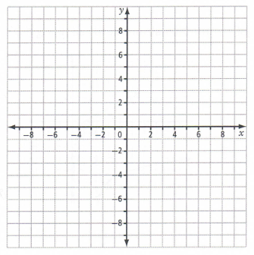
b) Determine the Domain and Range, the x- and y-intercepts and asymptotes of : $y=\log_{2}\left(\frac{1}{2}(x+2)\right)-3$
- Determine the transformations, in the right order to transform $y=\log_{c}x$ into the following functions:
a) $y=2\log_{4}\left(x+1\right)-8$
Which base function is transformed? ___________________
b) $y=ln\left(8-4x\right)$
Which base function is transformed? ___________________

