Introduction TEST
- Graph the following functions. Determine their domains, Ranges, exact values of the intercepts and vertex when relevant.
a) $y=-\frac{2}{3}x+5$ [3]
Domain: Range:
x-intercepts: y-intercept:
b) $y=-\frac{1}{2}x^{2}+4x-3$ [4]
Domain: Range:
x-intercepts: y-intercept:
Vertex:
c) $y=\left|5-x\right|$ [3]
Domain: Range:
x-intercepts: y-intercept:
e) $y=\sqrt{x-5}$ [3]
Domain: Range:
x-intercepts: y-intercept:
- Solve the following equations algebraically. Keep exact values. [17]
a) $3\left(x-5\right)=2x+1$ b) $\frac{x+4}{2}=\frac{2x-5}{3}$
c) $x^{2}-x-6=0$ by factoring d) $x^{2}-5x=7$
e) $\left|x+5\right|=4x-1$ f) $x-\sqrt{2x+3}=6$
- a) Rewrite in vertex form [1]
$A=-x^{2}+6x-5$
b) Rewrite in factored form. [2]
$B=2x^{2}+5x-3$

$$C=5x^{2}-20 \\ c) Rewrite in general form.$$ [1] $D=-2{\left(x-1\right)}^{2}+6$
- Determine the equations of the following graphs. [4]
a) b)
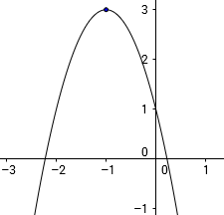 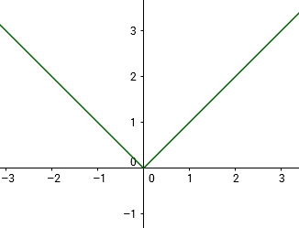
c)
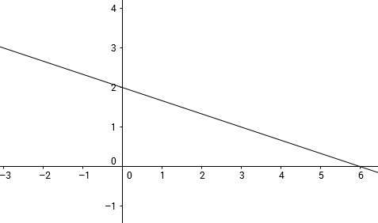
- a) Let $f\left(x\right)=2x+5$ and $g\left(x\right)=x^{2}$. Determine the expressions of the following composite functions: [2]
$$f∘g\left(x\right)= \\ g∘f\left(x\right)= \\ f\left(-x\right)= \\ g\left(-x\right)= \\ b) Express the following functions as compositions of usual functions:$$ [2]$$f\left(x\right)=3\sqrt{x}+2$$

$$g\left(x\right)={(-2x+3)}^{3}$$

