Thinking Classroom : Piecewise Functions

1- Graph the following function:
$$y=\left\{\begin{aligned}-2x-3 if x<0 \\ x-3 if x≥0\end{aligned}\right.$$

We say that this function is defined piecewise.

2- Determine the equation (defined piecewise) of the following function:
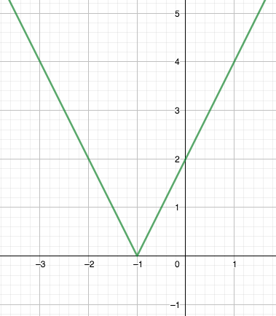
3- Imagine that a pool ball that is at point $(6,3)$ follows a trajectory described by
$y=x-3$ and then bounces on the x-axis.
Which equation could describe the full trajectory?

