QUIZ 4.1 – 4.2
- Sketch each angle in standard position, and convert each of them in radians (exact values).
a) 60$°$
b) 315$°$
c) -210$°$
d) 600$°$
- Sketch each angle in standard position, and convert each of them in degrees (exact values).
a) $\frac{π}{2}$
b) $\frac{4π}{3}$
c) $-\frac{2π}{9}$
- Determine two coterminal angles for each of the following angles. Choose one positive and one negative angle.
a) 349$°$
b) $\frac{9π}{4}$
- Determine, to the nearest hundredth, the arc length corresponding to a 195$°$ central angle on a circle with radius 15mm.
- Complete this diagram in radians for $-\frac{π}{2}≤θ≤2π$ and give the coordinates of the corresponding points on the unit circle.
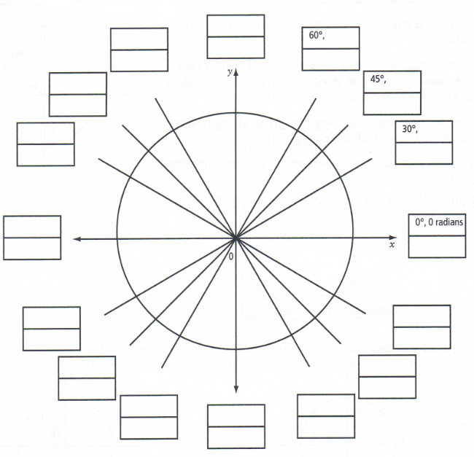
- a) What is the equation of the unit circle?
b) Determine if the following points are on the unit circle or not. Show your work.
i) $\left(-\frac{\sqrt{2}}{2}, -\frac{\sqrt{2}}{2}\right)$
ii) $\left(\frac{\sqrt{7}}{2}, -\frac{1}{7}\right)$
- Determine the missing coordinate for each of the following points on the unit circle. Make a drawing to illustrate your answer.
a) A $\left(x,\frac{5}{13}\right)$ in quadrant I.
b) B $\left(\frac{1}{6}, y\right)$ in quadrant IV
- Determine the angle $θ$ in standard position $0≤θ≤2π$, corresponding to the following coordinates:
a) P($θ$) = (-1, 0)
b) P($θ$) = $\left(\frac{\sqrt{3}}{2}, -\frac{1}{2}\right)$
c) P($θ$) = $\left(-\frac{1}{\sqrt{2}}, \frac{1}{\sqrt{2}}\right)$
- Determine the exact coordinates of the following points on the unit circle.
a) $P\left(-\frac{π}{4}\right)$
b) $P\left(\frac{23π}{6}\right)$

