READING A GRAPH – BALL THROW

Let’s consider the following graphs. Try to answer the following questions if it represents a ball throw. You can use approximations when needed.
a) What is the domain of the model? Should we use everything that is represented?
b) At what original height was the ball thrown?
c) What maximum height did it reach?
d) where or when did it reach its maximum height?
e) when or where did it fall on the ground?
f) what possible situation could it describe?
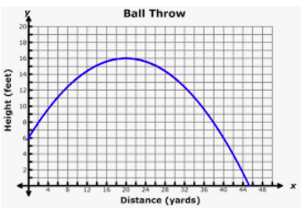

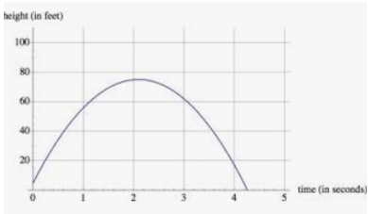

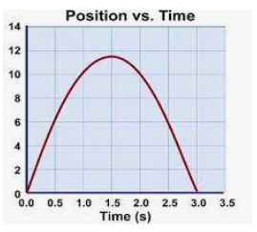

For this one, make 2 scenarios:
