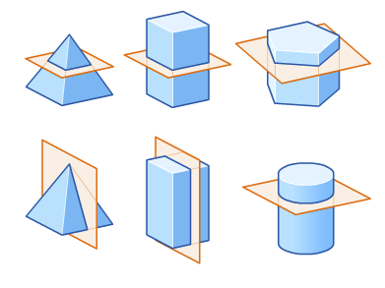

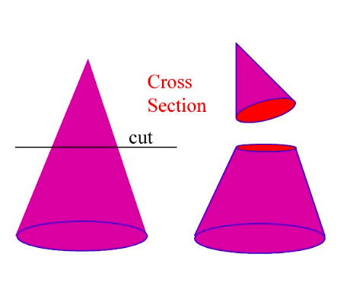
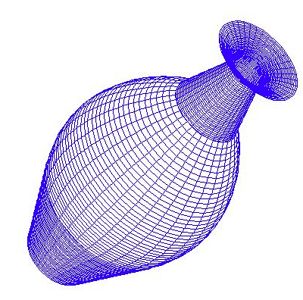

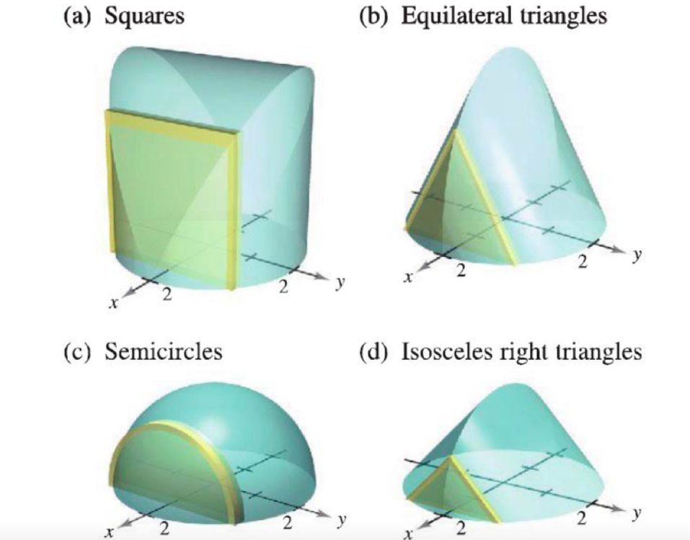

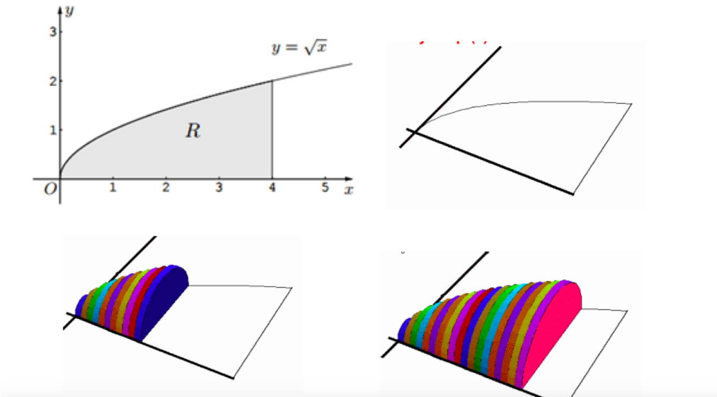

CROSS SECTIONS :

Animation Geogebra :
https://www.geogebra.org/m/YpqytNph#material/XArpgR3A

Lesson University of Houston :
https://online.math.uh.edu/HoustonACT/videocalculus/H.264/27-volumes1-H264.mov

SOLIDS OF REVOLUTION :

Animation geogebra :
https://www.geogebra.org/m/hhRJQyz9

Lesson Univerity of Houston :
https://online.math.uh.edu/HoustonACT/videocalculus/H.264/28-volumes2-H264.mov

